CSS BRITISH HISTORY · TOPIC 1 · KNOWLEDGE BASE
The Glorious Revolution and the Later Stuarts (1685–1714)
James II, the Revolution of 1688, William III and Mary II, Queen Anne, the wars against Louis XIV and the Union of 1707 — told from zero

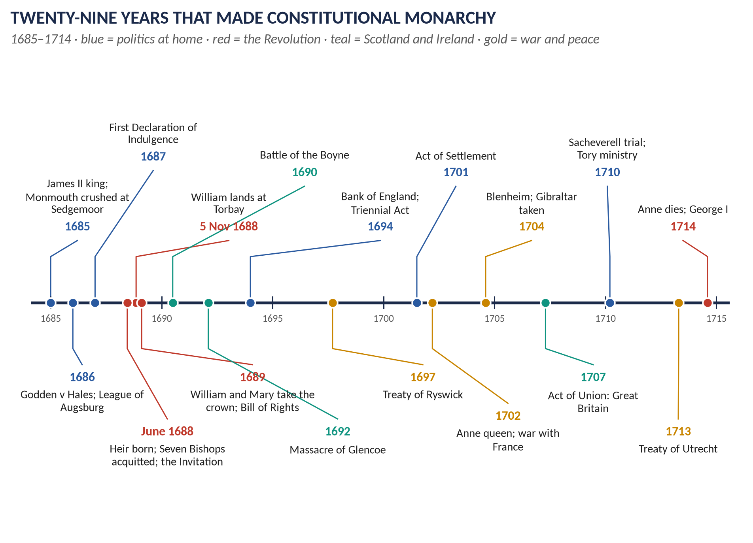
Syllabus heads I and III. Asked 8 times in 2015–2026 (the Revolution itself four times) and 7 MCQs in 2024–26. This document teaches the whole topic as a story first, then breaks it into chapters, and ends with 115 one-liners and a revision sheet that stands on its own.
Topic 1 of 10 · read with the companion document T1QA (every past question answered)
Contents
HOW TO USE THIS · Updating the contents
Right-click the contents → Update Field → Update entire table, before saving as PDF.

How to Use This Document 5
What this Topic covers 5
How this document is built 5
Part Zero — The ABC Before the Story 6
0.1 England in 1685 — a picture 6
0.2 Crown and Parliament — who governed? 6
The two royal powers at the centre of 1688 7
0.3 Why religion was politics 7
0.4 The Stuarts before 1685 — the story so far 8
0.5 Twenty words for this topic 9
Part One — The Story 10
1.1 A Catholic king in a Protestant country (1685–1687) 10
1.2 The year of crisis (1688) 10
1.3 William's invasion and James's collapse 11
1.4 The settlement (1689) 11
1.5 War in the three kingdoms (1689–1692) 12
1.6 William's war (1689–1697) 13
1.7 Anne and the War of the Spanish Succession (1702–1713) 13
1.8 One kingdom of Great Britain (1707) 14
1.9 The end of the Stuarts (1714) 15
Part Two — The Cast and the Time-line 16
2.1 The cast 16
2.2 The time-line 17
Part Three — The Chapters 19
Chapter 1 · James II and the Road to Revolution, 1685–1688 20
1.1 The king and his aims 20
Who James was 20
What he wanted 20
1.2 The policies, step by step 20
(i) The army 20
(ii) The dispensing power — Godden v Hales, 1686 21
(iii) The Church 21
(iv) The Declarations of Indulgence, 1687 and 1688 21
(v) Packing a Parliament 21
1.3 Why the Tories and the Church turned against him 21
1.4 The crisis of June 1688 22
The Immortal Seven 22
Chapter 2 · The Revolution of 1688–89 24
2.1 Why William came 24
William's motives 24
Why he could come in 1688 24
2.2 The collapse of James II 24
2.3 The Convention and the settlement of the crown 25
The problem 25
The debate 25
The compromise 25
2.4 Scotland and Ireland 25
Scotland 25
Ireland 26
2.5 How glorious was it? — the debate 26
Chapter 3 · The Revolution Settlement, 1689–1701 27
3.1 The laws of the Settlement 27
3.2 The Financial Revolution 28
3.3 What the Settlement did — and did not — do 28
Chapter 4 · The Church after 1688: Non-Jurors, High Churchmen and Latitudinarians 30
4.1 The problem the Revolution created for the Church 30
4.2 The Non-Jurors 30
4.3 The High Churchmen 30
4.4 The Latitudinarians 31
4.5 The three compared 31
Chapter 5 · William III and the Nine Years' War, 1689–1702 32
5.1 William as king 32
5.2 The War of the League of Augsburg (the Nine Years' War), 1688–1697 32
Causes — the long road 32
Causes — the trigger 32
The course of the war 33
The Treaty of Ryswick, September 1697 33
The significance of the war and the treaty 33
Chapter 6 · Queen Anne and the War of the Spanish Succession, 1702–1714 35
6.1 Anne as queen 35
6.2 The causes of the War of the Spanish Succession 35
6.3 The course of the war 35
Why Britain won the war's battles 36
6.4 How Anne changed the course of the war 36
6.5 The Peace of Utrecht, 1713 (and Rastatt, 1714) 36
6.6 The impact on the balance of power 37
Chapter 7 · The Union of England and Scotland, 1707 38
7.1 Two kingdoms, one king (1603–1707) 38
7.2 The crisis of 1698–1705 38
The Darien disaster 38
The constitutional collision 39
7.3 The treaty and its terms (1706–07) 39
7.4 Why the Scottish Parliament agreed 39
7.5 The consequences 40
Political 40
Constitutional 40
Economic and social (supporting evidence) 40
Part Four — Historians and Quotations 41
4.1 The historians 41
4.2 Lines worth quoting 41
Part Five — The Examiner's Record 43
Part Six — The One-Liner Bank 44
One-liners · Before 1685 and the ABC 44
One-liners · James II, 1685–1688 44
One-liners · The Revolution, 1688–1689 45
One-liners · The Revolution Settlement 46
One-liners · The Church after 1688 47
One-liners · William III and the Nine Years' War 47
One-liners · Queen Anne and the War of the Spanish Succession 48
One-liners · The Union of 1707 and the end of the Stuarts 48
Part Seven — Revision Sheet · Topic 1: The Glorious Revolution and the Later Stuarts, 1685–1714 50
R1.1 The story in ten lines 50
R1.2 Why the Revolution happened — the causes ranked 51
R1.3 Why "glorious"? — and how glorious? 51
R1.4 The Revolution Settlement, 1689–1701 51
R1.5 The Church after 1688 — three positions 52
R1.6 William's war and Ryswick (1689–97) 52
R1.7 Anne and the Spanish Succession (1702–13) 52
R1.8 The Union of 1707 52
R1.9 Ten dates to write in every answer 53

How to Use This Document

What this Topic covers
This is Topic 1 of ten. It covers the twenty-nine years from the accession of James II in 1685 to the death of Queen Anne in 1714: the Glorious Revolution of 1688–89, the reigns of William III and Mary II and of Anne, the two great wars against Louis XIV of France, and the Union of England and Scotland in 1707. It covers syllabus Head I (the Glorious Revolution) and Head III (the Union of England and Scotland).
WHAT THE EXAMINER HAS ASKED · Why this topic matters
Eight descriptive questions in 2015–2026: the Revolution itself in 2015, 2018, 2019 and 2023; the wars in 2015 and 2025; the Church after 1688 in 2021; the Union of 1707 in 2021. Plus seven MCQs in the last three objective papers — one of the heaviest objective topics. The full record is in Part Five.

How this document is built
1. Part Zero — The ABC. For readers starting from nothing: what England was like in 1685, what "Crown" and "Parliament" meant, why religion was politics, and what happened to the Stuarts before 1685.
2. Part One — The Story. The whole topic told as a story in simple words. Read it first, twice.
3. Part Two — The Cast and the Time-line. Who is who; what happened when.
4. Part Three — The Chapters. Seven chapters that break the story into causes, events, results and significance, with maps and diagrams.
5. Part Four — Historians and Quotations. The debate, and the lines worth quoting.
6. Part Five — The Examiner's Record. Every question set on this topic, and where it is answered.
7. Part Six — The One-Liner Bank. 115 one-line questions and answers.
8. Part Seven — The Revision Sheet. The whole topic in a few pages, complete on its own.

Part Zero — The ABC Before the Story
THE STORY IN SIMPLE WORDS · Start here if you know nothing
To understand 1688 you need four things: what England was like, how it was governed, why religion mattered so much, and what had happened to its kings in the eighty years before. This Part gives you all four in plain words.

0.1 England in 1685 — a picture
- About five million people lived in England and Wales; Scotland had about one million and Ireland about two million. London, with more than half a million people, was the largest city in Europe after Paris and Constantinople.
- Most people worked on the land. Wealth and power belonged to landowners: a few hundred great noble families (the peers, who sat in the House of Lords) and several thousand gentry (country gentlemen who ran local government as Justices of the Peace and sat in the House of Commons).
- England was a Protestant country. The official church, the Church of England, was headed by the monarch. About nineteen people in twenty belonged to it. There were small numbers of Protestant Dissenters (Presbyterians, Baptists, Quakers) outside it, and a small, feared minority of Catholics — perhaps one in fifty.
- England was not yet a great power. France, under Louis XIV, was the strongest state in Europe, with an army of well over 200,000 men. The Dutch Republic was the great trading nation. England's army was small, and Parliament distrusted it.

0.2 Crown and Parliament — who governed?
In 1685 England was a monarchy. The king chose his ministers, ran foreign policy, commanded the army, made war and peace, appointed judges and bishops, and summoned and dismissed Parliament when he chose.
But the king was not all-powerful. Parliament — the House of Lords and the elected House of Commons — had to agree to new laws and, above all, to new taxes. A king who wanted to fight a war or keep a large army needed money, and for money he needed Parliament.
KEY IDEA · The question that runs through the whole seventeenth century
Who has the final say — the king or Parliament? The Stuart kings believed they ruled by the divine right of kings: God had placed them on the throne and they answered to God alone. Parliament believed in the "ancient constitution": the king must rule according to law, and law was made with Parliament's consent. The Revolution of 1688 answered the question — in Parliament's favour.

The two royal powers at the centre of 1688
- The suspending power — the king's claim to set aside (suspend) an Act of Parliament altogether.
- The dispensing power — the king's claim to excuse (dispense) a particular person from obeying a particular law.
James II used both to help Catholics. The Bill of Rights of 1689 abolished the first and limited the second.

0.3 Why religion was politics
In the seventeenth century religion was not a private matter. It decided who could hold office, who could be trusted, and what kind of state England would be.
- Protestants associated Catholicism with absolute monarchy and foreign power. The model was France: Louis XIV governed without a parliament and, in 1685, revoked the Edict of Nantes, ending toleration for French Protestants (Huguenots). About 200,000 fled abroad, many to England, bringing stories of persecution.
- English memory was full of Catholic "plots": the Gunpowder Plot (1605) and the invented Popish Plot (1678), which led to the execution of innocent Catholics.
- By law, Catholics could not hold public office: the Test Acts of 1673 and 1678 required every office-holder and MP to take communion in the Church of England and deny Catholic doctrine.
TRAP — DO NOT FALL INTO IT · Do not read 1688 as a modern fight for "freedom of religion"
The men of 1688 wanted freedom for Protestants, and a Protestant monarchy. The Toleration Act of 1689 helped Protestant Dissenters but gave nothing to Catholics. In Ireland the Revolution led to harsh Penal Laws against the Catholic majority.

0.4 The Stuarts before 1685 — the story so far
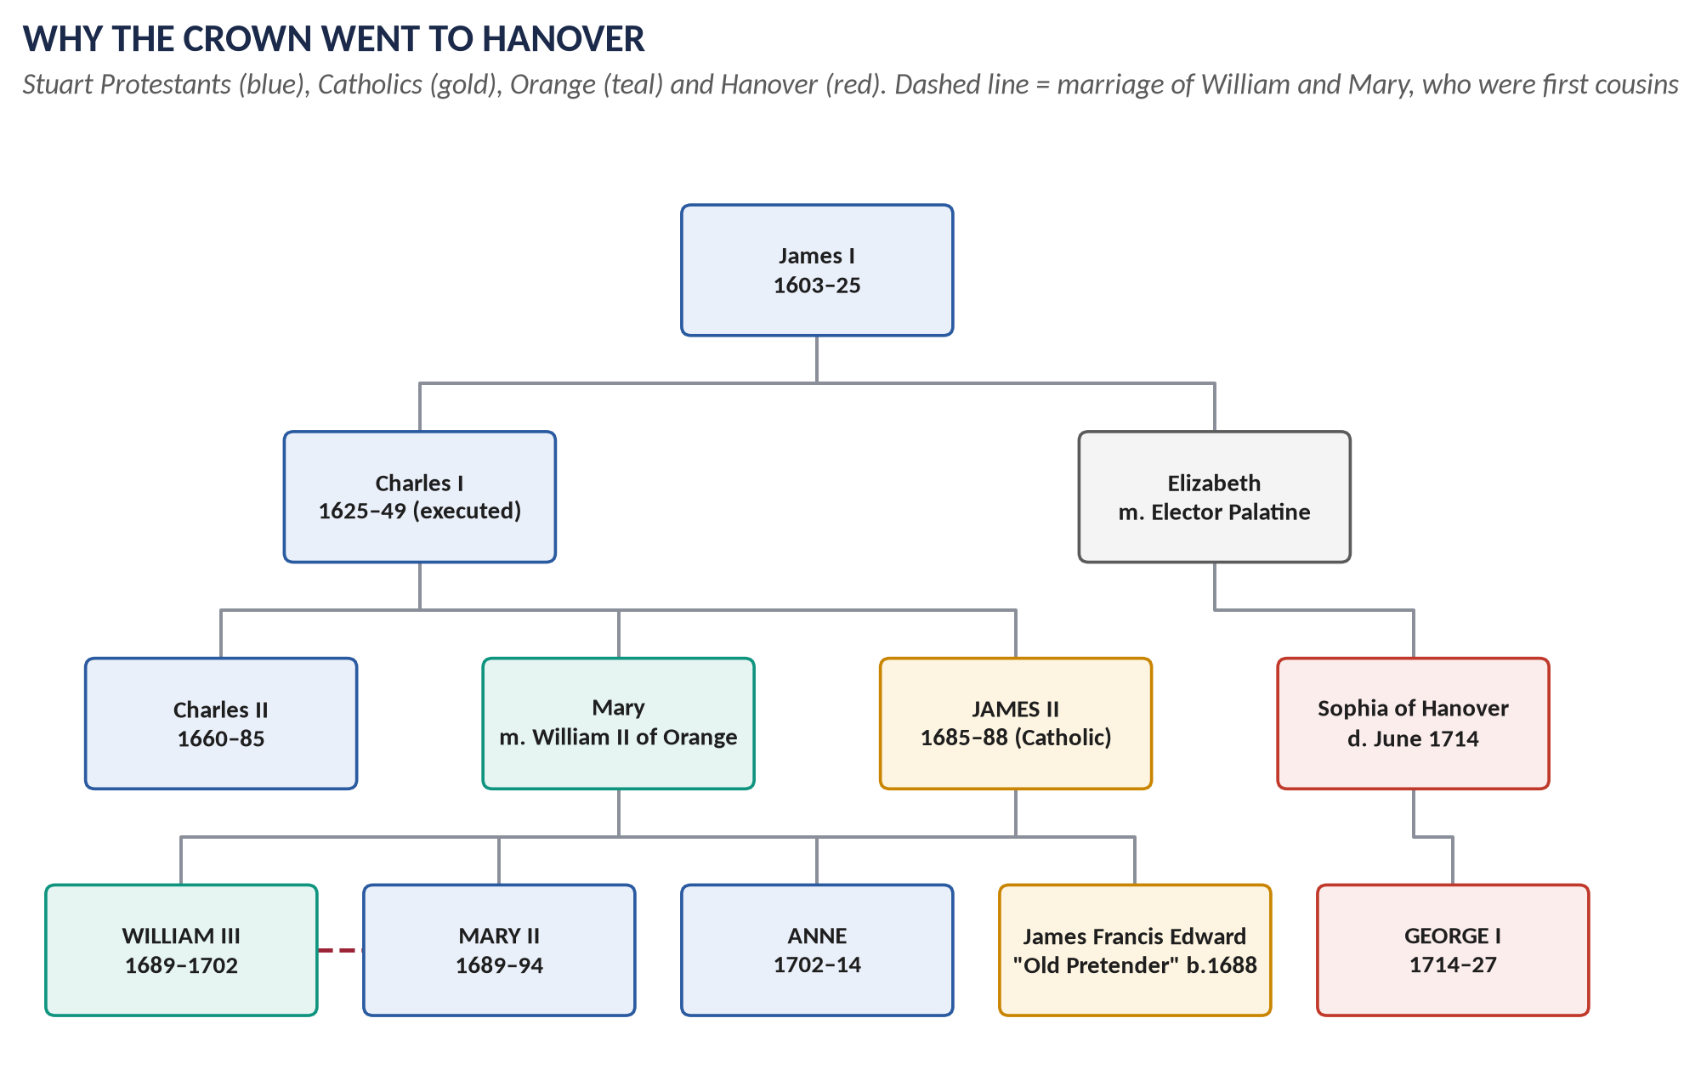
Figure 1 · The Stuart family and the Protestant succession. Mary II and Anne were James II's Protestant daughters; George I inherited through Sophia of Hanover, granddaughter of James I.
Date | What happened
1603 | James VI of Scotland becomes James I of England: the two crowns are joined in one person (the Union of the Crowns), but the kingdoms stay separate.
1625–49 | Charles I quarrels with Parliament over taxes, religion and his powers. He rules without Parliament for eleven years (1629–40).
1642–49 | Civil War between King and Parliament. Parliament's New Model Army wins; Charles I is executed in January 1649.
1649–60 | England is a republic; Oliver Cromwell rules as Lord Protector with an army. Many remember this as military rule.
1660 | The Restoration: Charles I's son returns as Charles II. The Church of England is restored. Parliament and king must now work together.
1678–81 | The Popish Plot panic and the Exclusion Crisis: MPs try to pass a law excluding Charles's Catholic brother James from the throne. They fail. The two sides get nicknames that last: Whigs (for exclusion) and Tories (against it).
1685 | Charles II dies; his brother becomes James II — England's first openly Catholic king since Mary I (1553–58).

THE STORY IN SIMPLE WORDS · Why this back-story matters
Everyone in 1688 remembered the Civil War and Cromwell. They did not want another war, and they did not want another army ruling the country. That is why the political class looked for a quick, lawful, bloodless change — and why the Revolution of 1688 is called "glorious".

0.5 Twenty words for this topic
Word | Meaning
Glorious Revolution | The replacement of James II by William III and Mary II in 1688–89, followed by laws limiting the Crown.
Declaration of Indulgence | A royal order suspending the laws against Catholics and Dissenters (1687, 1688).
Test Acts | Laws of 1673 and 1678 barring non-Anglicans (in practice, Catholics) from office and Parliament.
Immortal Seven | The seven leading men who signed the invitation to William of Orange on 30 June 1688.
Convention Parliament | The parliament that met in January 1689 without a king's summons and offered the crown to William and Mary.
Declaration of Right / Bill of Rights | The list of James's illegal acts and of Parliament's rights, read to William and Mary in February 1689; passed as the Bill of Rights in December 1689.
Revolution Settlement | All the laws of 1689–1701 that fixed the new constitution.
Toleration Act | The 1689 law allowing Protestant Dissenters to worship freely (but not to hold office).
Non-Jurors | Clergy who refused ("non-juring" = not swearing) the oath to William and Mary.
Latitudinarian | A moderate, "broad" Anglican who valued reason and tolerance over strict doctrine.
High Church | Anglicans who stressed the authority and privileges of the Church and its bishops.
Jacobite | A supporter of James II and his descendants (Latin Jacobus = James).
Financial Revolution | The new system of public credit: the Bank of England (1694), a permanent National Debt, taxes voted by Parliament.
Grand Alliance | The coalition (England, the Dutch Republic, the Emperor and others) against Louis XIV, formed in 1689 and renewed in 1701.
Balance of power | The principle that no single state should dominate Europe. Written into the Treaty of Utrecht (1713).
Act of Settlement | The 1701 law giving the crown, after Anne, to the Protestant House of Hanover.
Act of Union | The 1707 law uniting England and Scotland as the Kingdom of Great Britain.
Darien scheme | Scotland's failed colony in Panama (1698–1700), which lost a huge share of Scotland's capital.
Asiento | The contract to supply enslaved Africans to Spanish America, granted to Britain at Utrecht.
Rage of party | The fierce Whig–Tory conflict of the years 1689–1714.

Part One — The Story
THE STORY IN SIMPLE WORDS · The Glorious Revolution and the later Stuarts, told simply
Read this Part as a story, from beginning to end, before you read anything else. Every name and date here is explained again, in more detail, in Part Three.

1.1 A Catholic king in a Protestant country (1685–1687)
When Charles II died in February 1685, his brother James, Duke of York, became king. James was fifty-one, brave, stubborn and honest about his faith: he had become a Catholic in the 1660s. Many Protestants had tried to keep him from the throne, but in 1685 there was little opposition. The Tories believed that a lawful king must be obeyed, and James promised to protect the Church of England.
Within months he faced a rebellion. The Duke of Monmouth, Charles II's illegitimate Protestant son, landed in the West Country and claimed the throne. His army of farmers and craftsmen was destroyed at Sedgemoor in July 1685. Monmouth was beheaded, and in the "Bloody Assizes" Judge Jeffreys sent about 250 rebels to the gallows and some 800 to slavery in the West Indies.
James drew two lessons from the rebellion: he needed a large standing army, and he could trust Catholic officers in it. Both alarmed Parliament. In November 1685 MPs politely refused to accept Catholic officers. James prorogued (suspended) Parliament. It never met again in his reign.
He then used his royal powers instead. In Godden v Hales (1686) his judges ruled that the king could dispense individuals from the Test Acts. Catholics were appointed to the army, the Privy Council, the universities and even to run Magdalen College, Oxford. A new Ecclesiastical Commission suspended the Bishop of London, Henry Compton, for refusing to discipline an anti-Catholic preacher.
In April 1687 James went further. His Declaration of Indulgence suspended all the laws against Catholics and Protestant Dissenters. It offered freedom of worship to everyone. James hoped that grateful Dissenters would help him elect a Parliament that would make it permanent. His agents questioned every local official — would they support repeal of the Test Acts? — and dismissed those who would not.

1.2 The year of crisis (1688)
In April 1688 James reissued the Declaration and ordered every Anglican clergyman to read it from the pulpit. Archbishop Sancroft and six bishops petitioned against the order, saying the suspending power was illegal. James had the Seven Bishops sent to the Tower and tried for seditious libel.
Two events in June turned alarm into crisis:
- On 10 June 1688 James's queen, Mary of Modena, gave birth to a son, James Francis Edward. Until then the heirs had been James's Protestant daughters, Mary (married to William of Orange) and Anne. Now England faced a Catholic dynasty. Many Protestants refused to believe the baby was real and spread the story that he had been smuggled into the queen's bed in a warming-pan.
- On 30 June 1688 a London jury acquitted the Seven Bishops. Crowds cheered in the streets — and the king's own soldiers cheered on Hounslow Heath.
That same night seven leading men — Whigs and Tories — signed a letter inviting William of Orange to come to England with an army. They are remembered as the Immortal Seven.

1.3 William's invasion and James's collapse
William of Orange was the leader (stadtholder) of the Dutch Republic, a Protestant, James's nephew and husband of James's daughter Mary. His life's work was resisting Louis XIV. He wanted England's wealth and navy on his side — and he feared that James might join Louis.
In September 1688 Louis sent his armies east into the Rhineland instead of north against the Dutch. The Dutch States-General let William go. A fleet of about 450 ships carrying some 15,000 soldiers, driven by an east wind that Protestants called the "Protestant wind", landed at Torbay in Devon on 5 November 1688.
James marched to meet him with an army nearly twice as large. But at Salisbury his commanders began to desert — including his favourite officer, John Churchill (the future Duke of Marlborough). His daughter Anne fled to join the rebels. James suffered heavy nosebleeds, lost his nerve, and fell back to London. He sent his wife and son to France and, on 11 December, fled himself, dropping the Great Seal into the Thames. Fishermen caught him in Kent and brought him back, but William let him escape again; on 23 December 1688 he left for France for good.

1.4 The settlement (1689)
What now? A Convention (a parliament meeting without a royal summons) assembled in January 1689. The Commons voted that James had "abdicated" and that the throne was "vacant". Tories wanted Mary as queen alone, or a regency; William refused to be his wife's servant. The compromise: William III and Mary II would reign jointly, with William holding the executive power.
On 13 February 1689 they accepted the crown and heard the Declaration of Right read to them — a list of James's illegal acts and of the rights of Parliament. It became the Bill of Rights in December 1689. Together with other laws — the Mutiny Act, the Toleration Act, the Triennial Act and, in 1701, the Act of Settlement — it made up the Revolution Settlement. From now on the monarch could not suspend laws, keep a peacetime army, or raise taxes without Parliament — and Parliament would meet every year.

1.5 War in the three kingdoms (1689–1692)
In England the change had been almost bloodless. Elsewhere it was not.
- Scotland accepted William and Mary through the Claim of Right (1689) and restored the Presbyterian church. Highland Jacobites under Viscount Dundee won at Killiecrankie (July 1689) but lost their leader there. In February 1692 government soldiers massacred about thirty-eight members of the MacDonald clan at Glencoe for being late in taking the oath — a crime that was never forgotten.
- Ireland was mostly Catholic and loyal to James. James landed at Kinsale in March 1689 with French help. Protestant Derry held out through a famous siege. William won the Battle of the Boyne on 1 July 1690 (12 July in the modern calendar), then Aughrim (1691); the Treaty of Limerick (1691) ended the war. The Irish Parliament, controlled by Protestants, then passed the Penal Laws, shutting Catholics out of land, office and the professions for a century.
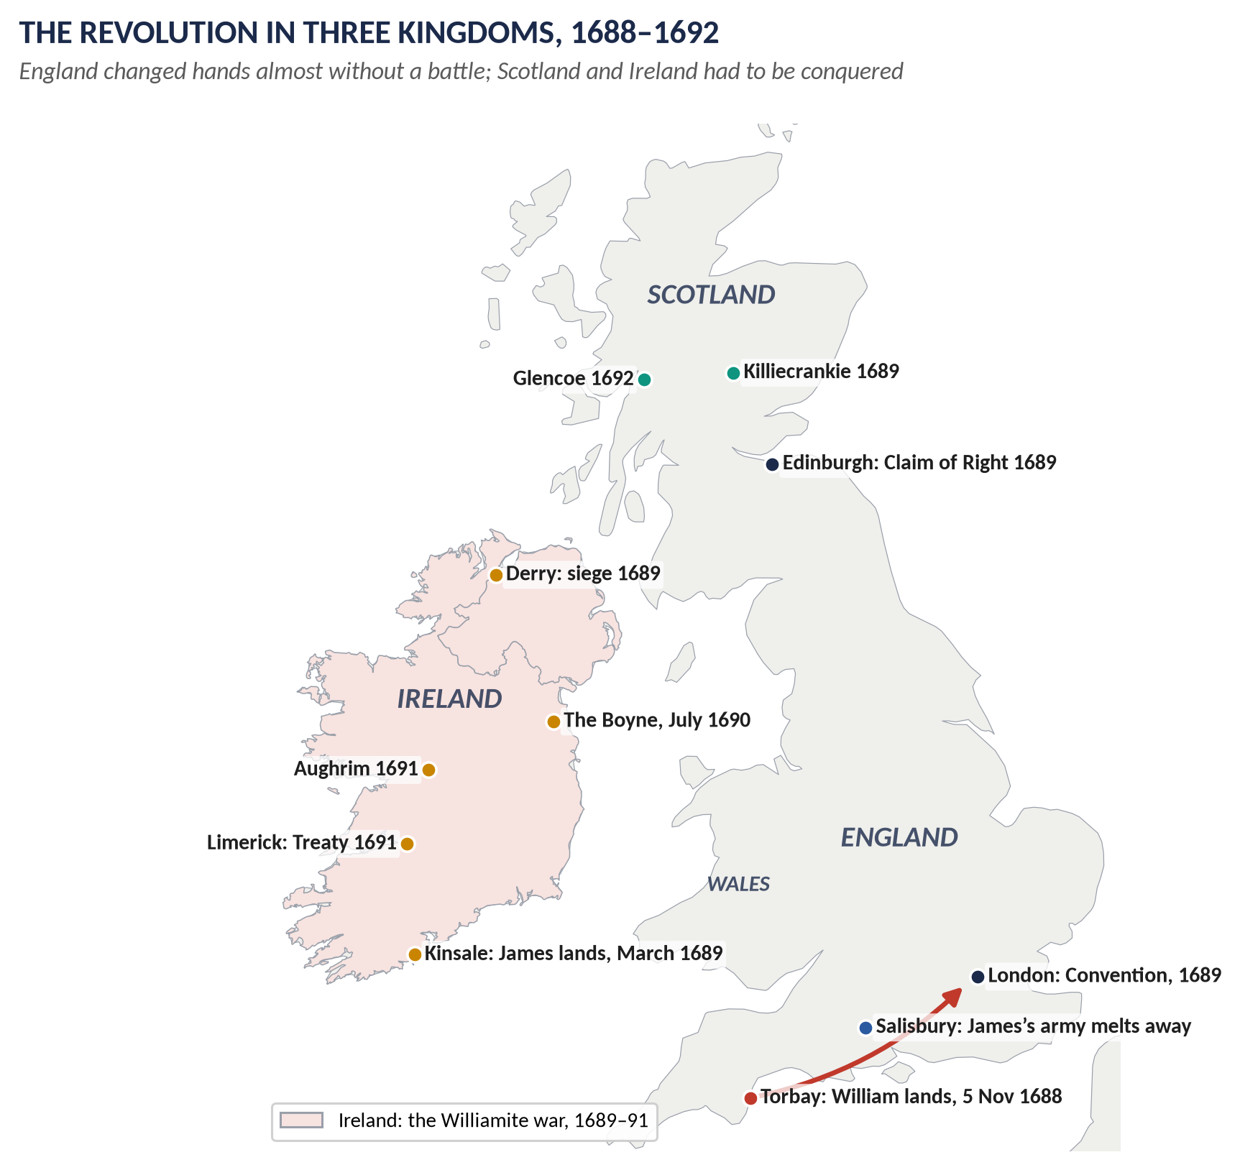
Figure 2 · The Revolution in the three kingdoms, 1688–1692: William's march on London, the Jacobite fight in Scotland and the Williamite war in Ireland.

1.6 William's war (1689–1697)
William brought England into the Nine Years' War (also called the War of the League of Augsburg) against Louis XIV. England joined the Grand Alliance with the Dutch Republic, the Emperor and Spain. The French won at sea at Beachy Head (1690) but lost at Barfleur–La Hogue (1692); on land William lost battles in Flanders but retook the great fortress of Namur (1695). By 1697 both sides were exhausted. In the Treaty of Ryswick Louis recognised William as King of England and promised not to help James.
To pay for the war, England invented new ways of raising money: the Bank of England (1694), a permanent National Debt backed by taxes voted by Parliament, and a land tax. This Financial Revolution made England able to fight wars on a scale never seen before. It also tied the monarchy to Parliament, which voted the money every year.
Queen Mary died of smallpox in December 1694; William ruled alone until he died after a riding accident in March 1702.

1.7 Anne and the War of the Spanish Succession (1702–1713)
Mary's sister Anne became queen in 1702. The great European question now was Spain: its childless king, Charles II, had died in 1700 leaving his whole empire to Louis XIV's grandson, Philip of Anjou. If France and Spain were joined under one family, the balance of power would be destroyed. When Louis also recognised James II's son as "James III" (1701), England went to war again.
Anne trusted John Churchill, Duke of Marlborough as commander and his friend Sidney Godolphin to raise the money. Marlborough won a string of famous victories: Blenheim (1704), which saved Vienna and knocked Bavaria out of the war; Ramillies (1706); Oudenarde (1708); and the bloody Malplaquet (1709). The navy took Gibraltar (1704) and Minorca (1708).
But the war dragged on and grew unpopular. Anne quarrelled with Marlborough's wife Sarah; the Tories won the election of 1710; Robert Harley and Henry St John made peace behind the allies' backs. Marlborough was dismissed in 1711. The Treaty of Utrecht (1713) let Philip keep Spain on condition that France and Spain were never united; Austria took Spain's lands in Italy and the Netherlands; and Britain gained Gibraltar, Minorca, Newfoundland, Nova Scotia, Hudson Bay and the asiento (the right to sell enslaved Africans to Spanish America). Louis recognised the Protestant succession.
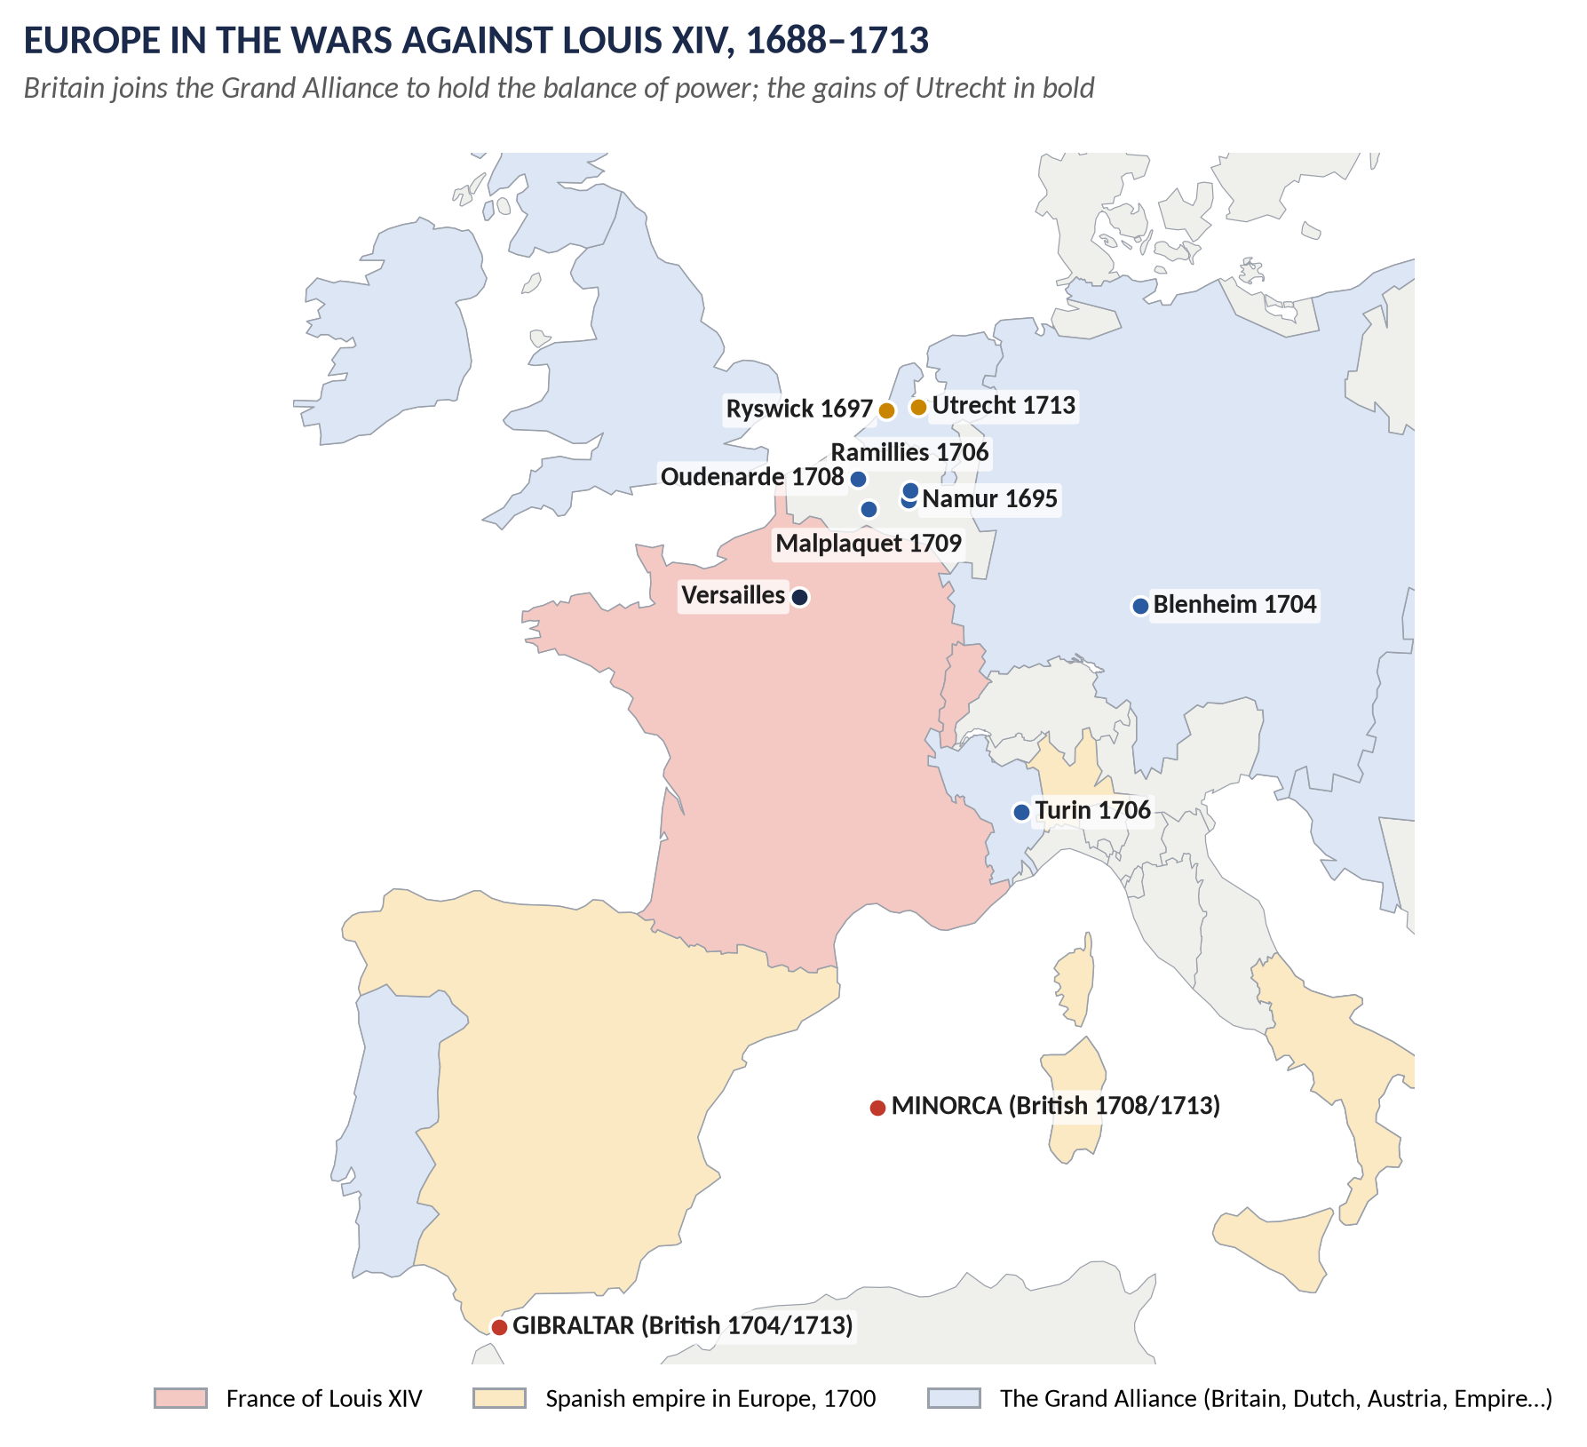
Figure 3 · Europe in the wars against Louis XIV, 1688–1713: the Grand Alliance, the great battles, and the Mediterranean bases Britain kept at Utrecht.

1.8 One kingdom of Great Britain (1707)
England and Scotland had shared a king since 1603, but not a parliament. The arrangement nearly broke down under Anne. The Act of Settlement (1701) had given England's crown to Hanover, but Scotland had not agreed. The Scottish Parliament, angry after the failure of its Darien colony in Panama (1698–1700), passed the Act of Security (1704): Scotland might choose a different successor. England replied with the Alien Act (1705): unless the Scots negotiated, they would be treated as foreigners and their trade with England would stop.
Commissioners from both sides agreed a treaty in 1706. The Act of Union made the two countries one Kingdom of Great Britain from 1 May 1707, with one Parliament at Westminster in which Scotland had 45 MPs and 16 peers. Scotland kept its own law, its own courts and its Presbyterian Church. It gained free trade with England and its colonies, and a payment called the Equivalent (£398,085) to compensate, among other things, those who had lost money in Darien. Many Scots called it a sell-out — "bought and sold for English gold", as Robert Burns later wrote — but the Union survived.

1.9 The end of the Stuarts (1714)
Anne's reign was also the high point of the "rage of party" between Whigs (for the war, for the Dissenters, for the Hanoverian succession) and Tories (for the Church, for peace, and — some of them — secretly for the exiled "James III"). In 1710 the High Church preacher Henry Sacheverell was tried for attacking the Revolution's principles; his light sentence was a Tory triumph.
Anne had seventeen pregnancies but no surviving child. When she died on 1 August 1714, the Act of Settlement worked exactly as planned: the crown passed to George I, Elector of Hanover, great-grandson of James I. The Stuart dynasty had ended, and the age of the Hanoverians — Topic 2 — had begun.
VERDICT · The story in one sentence
In twenty-nine years England turned a Catholic, would-be absolute monarchy into a Protestant, parliamentary one; fought France to a standstill; united with Scotland; and emerged in 1714 as Great Britain, a constitutional monarchy and a great power.

Part Two — The Cast and the Time-line

2.1 The cast
Person | Dates | Who they were — in one line
James II | 1633–1701; king 1685–88 | Catholic king whose policies caused the Revolution; died in exile at Saint-Germain.
Mary of Modena | 1658–1718 | James's Italian Catholic queen; mother of the "warming-pan" prince.
James Francis Edward Stuart | 1688–1766 | James's son, the "Old Pretender" ("James III" to Jacobites).
William III | 1650–1702; king 1689–1702 | Prince of Orange, Dutch stadtholder, James's nephew and son-in-law; led Europe against Louis XIV.
Mary II | 1662–94; queen 1689–94 | James's elder Protestant daughter; co-ruled with William.
Anne | 1665–1714; queen 1702–14 | James's younger Protestant daughter; last Stuart monarch.
Louis XIV | 1638–1715 | King of France; the most powerful ruler in Europe; the enemy of both wars.
Duke of Monmouth | 1649–85 | Charles II's illegitimate son; led the failed Protestant rising of 1685.
Judge George Jeffreys | 1645–89 | Lord Chief Justice of the "Bloody Assizes"; later Lord Chancellor.
Archbishop William Sancroft | 1617–93 | Led the Seven Bishops; later refused the oath to William — the leading Non-Juror.
John Churchill, Duke of Marlborough | 1650–1722 | Deserted James in 1688; Anne's captain-general; victor of Blenheim.
Sarah Churchill | 1660–1744 | Marlborough's wife and Anne's closest friend until their quarrel.
Sidney Godolphin | 1645–1712 | Lord Treasurer 1702–10; paid for Marlborough's wars.
Robert Harley | 1661–1724 | Tory leader who ended the war; Earl of Oxford.
Henry St John, Viscount Bolingbroke | 1678–1751 | Tory minister who negotiated Utrecht; later fled to the Jacobites.
Henry Sacheverell | 1674–1724 | High Church preacher whose trial (1710) destroyed the Whig ministry.
John Locke | 1632–1704 | Philosopher whose Two Treatises of Government (1689) justified resistance to tyranny.
Viscount Dundee | 1648–89 | Scottish Jacobite general, killed winning at Killiecrankie.
Duke of Queensberry | 1662–1711 | Chief manager of the Union in the Scottish Parliament.
George I | 1660–1727 | Elector of Hanover; king from 1714.

2.2 The time-line
Figure 4 · The twenty-nine years of Topic 1 at a glance.
Date | Event
Feb 1685 | Death of Charles II; accession of James II
Jul 1685 | Monmouth defeated at Sedgemoor; the Bloody Assizes follow
Nov 1685 | Parliament objects to Catholic officers; prorogued, never to meet again
1686 | Godden v Hales upholds the dispensing power; Ecclesiastical Commission; League of Augsburg formed in Europe (July)
Apr 1687 | First Declaration of Indulgence
Apr–May 1688 | Declaration reissued and ordered read in churches; the Seven Bishops petition
10 Jun 1688 | Birth of James Francis Edward
30 Jun 1688 | Seven Bishops acquitted; the Invitation to William
5 Nov 1688 | William lands at Torbay
23 Dec 1688 | James flees to France for good
13 Feb 1689 | William and Mary accept the crown and the Declaration of Right
1689 | Toleration Act; Mutiny Act; Scottish Claim of Right; Killiecrankie; siege of Derry; England at war with France (May)
Dec 1689 | Bill of Rights
1 Jul 1690 | Battle of the Boyne
1691 | Aughrim; Treaty of Limerick
Feb 1692 | Massacre of Glencoe; (May) naval victory of Barfleur–La Hogue
1694 | Bank of England; Triennial Act; death of Mary II
1695 | William retakes Namur; the Licensing Act lapses — a free press
1697 | Treaty of Ryswick
1698–1700 | Scotland's Darien colony fails
1700 | Charles II of Spain dies, leaving his empire to Philip of Anjou
1701 | Act of Settlement; Grand Alliance renewed; James II dies; Louis recognises "James III"
Mar 1702 | Death of William III; accession of Anne; war declared (May)
1704 | Blenheim (13 August); Gibraltar taken; Scottish Act of Security
1705 | English Alien Act
1706 | Ramillies; Union treaty negotiated
1 May 1707 | Union of England and Scotland
1708 | Oudenarde; Minorca taken; a French-backed Jacobite landing fails
1709 | Malplaquet
1710 | Sacheverell trial; Tory victory; Harley in power
1711 | Marlborough dismissed; twelve Tory peers created (Dec 1711–Jan 1712)
1713 | Treaty of Utrecht
1 Aug 1714 | Death of Anne; accession of George I

Part Three — The Chapters
HOW TO USE THIS · How the chapters work
Each chapter takes one part of the story and breaks it down the way an examiner does: background → causes → what happened → results → significance → the debate. Each ends with a box showing where it has been asked.

Chapter 1 · James II and the Road to Revolution, 1685–1688

1.1 The king and his aims

Who James was
- Born 1633, second son of Charles I; spent the 1650s in exile in France and served in the French and Spanish armies.
- Lord High Admiral under Charles II; a competent commander at sea.
- Became a Catholic around 1669; resigned his offices after the Test Act of 1673 rather than deny his faith.
- Survived the Exclusion Crisis (1679–81) because the Tories and the king defended hereditary right.

What he wanted
Historians still argue about James's aims. Three views:
1. The Whig view (Macaulay): James meant to make England Catholic and absolute on the French model.
2. The revisionist view (Miller, Sowerby): he wanted equality for Catholics — the right to worship and hold office — and a genuine toleration for all, which he believed would lead many to convert freely.
3. The middle view: whatever his motives, his methods — the prerogative, the army, purges of office-holders — looked exactly like absolutism, and that is what mattered in 1688.
KEY IDEA · The point for the exam
James's aims may have been toleration; his methods were arbitrary. The Revolution was a reaction to the methods.

1.2 The policies, step by step

(i) The army
- After Monmouth's rebellion (1685) the English army rose from about 9,000 to nearly 20,000, and to some 34,000 by 1688 — with more in Scotland and Ireland.
- A permanent camp on Hounslow Heath near London looked like a threat to the capital.
- Catholic officers were commissioned in defiance of the Test Acts.
- In Ireland, Lord Tyrconnell turned the army into a largely Catholic force.

(ii) The dispensing power — Godden v Hales, 1686
- A test case: Sir Edward Hales, a Catholic colonel, was prosecuted for holding office without taking the Test.
- James first replaced judges who disagreed with him; the remaining judges ruled eleven to one that the king could dispense with the penal laws in individual cases.
- This opened the way to Catholic appointments across government.

(iii) The Church
- The Ecclesiastical Commission (1686), a court like the one abolished in 1641, suspended Bishop Compton of London.
- Magdalen College, Oxford (1687): James forced a Catholic president on the Fellows and expelled the 25 who refused — an attack on property (their fellowships) as well as religion.
- Catholic chapels opened; the papal nuncio was received publicly (1687).

(iv) The Declarations of Indulgence, 1687 and 1688
- 4 April 1687: suspended all the penal laws and the Test Acts; allowed Catholics and Dissenters to worship in public.
- 27 April 1688: reissued, with an order (4 May) that it be read in every church on two Sundays.
- The first Declaration was a suspension of laws — far wider than a dispensation. It was exactly the power Parliament had denied Charles II in 1673.

(v) Packing a Parliament
- James needed an Act of Parliament to make toleration permanent. So he set out to manage the elections.
- The Three Questions (late 1687) were put to every Justice of the Peace and Lord Lieutenant: would they support repeal of the Test Acts and penal laws? Would they vote for candidates who did? Would they live peaceably with those of all religions?
- Most refused or gave evasive answers; hundreds were dismissed. Town corporations were remodelled by royal "regulators" to put in Dissenters and Catholics.
- Elections were planned for November 1688. The invasion came first.

1.3 Why the Tories and the Church turned against him
THE STORY IN SIMPLE WORDS
The Tories had saved James's right to the throne in 1681. They believed in passive obedience: a Christian must not resist the king. But they also believed the king would protect the Church of England. When James attacked the Church, they faced an impossible choice — and when his son was born, the choice became urgent.

1. He attacked the Church's position: Compton, Magdalen, the Declarations, the Seven Bishops.
2. He dismissed Tory ministers: his own brothers-in-law, the Earl of Rochester and the Earl of Clarendon, in January 1687.
3. He allied with the Dissenters, the Tories' old enemies.
4. He threatened property: the Magdalen Fellows lost their livelihoods; local gentry lost their offices.
5. He looked like Louis XIV: the revocation of the Edict of Nantes (1685) made "popery and arbitrary government" seem a real prospect.

1.4 The crisis of June 1688
Date | Event | Why it mattered
18 May | The Seven Bishops petition against reading the Declaration | The Church's leaders openly defy the king
8 June | The bishops sent to the Tower | Popular sympathy swings violently to them
10 June | Birth of James Francis Edward | A Catholic heir: James's policies would not die with him
30 June | The bishops acquitted | Law and public opinion both against the king
30 June | The Invitation to William signed | The political class turns to force

The Immortal Seven
Four Whigs and three Tories signed: the Earl of Danby (the leading Tory), the Earl of Devonshire, the Earl of Shrewsbury, Viscount Lumley, Bishop Compton, Edward Russell and Henry Sydney. That Whigs and Tories — including a bishop — signed together shows how far James had united his enemies.
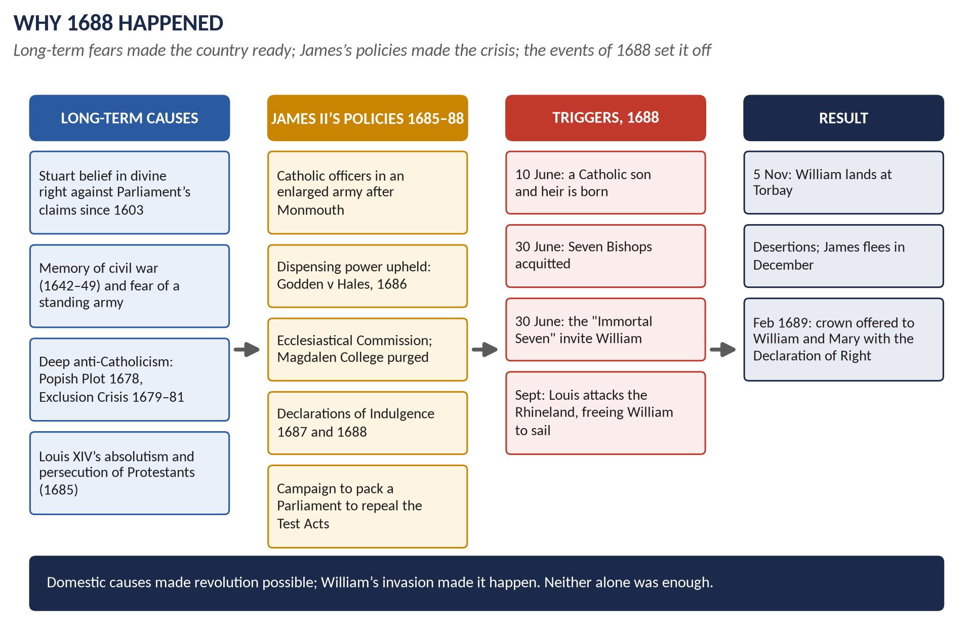
Figure 5 · The causes of the Revolution as a chain: long-term fears, James's policies, the triggers of 1688, and the result.
WHAT THE EXAMINER HAS ASKED · Where Chapter 1 has been asked
2015 P1 Q2 (what forced James to issue the Declarations of Indulgence) · 2018 Q2 (what led to the Glorious Revolution) · 2023 Q2 (how it occurred). All answered in full in T1QA.

Chapter 2 · The Revolution of 1688–89

2.1 Why William came

William's motives
- Europe first: William's life was a struggle against Louis XIV, who had invaded the Dutch Republic in 1672. England's navy and money could decide the next war.
- Fear of an Anglo-French alliance: James's Catholic policies and French connections made William fear England would side with Louis.
- His wife's inheritance: the birth of a prince in June 1688 destroyed Mary's expectation of the throne.
- An invitation gave him legitimacy: he could present himself as the defender of English laws and religion, not as a conqueror. His Declaration (published October 1688) promised only a "free Parliament".

Why he could come in 1688
- In September 1688 Louis XIV attacked Philippsburg in the Rhineland rather than the Dutch. The Dutch States-General agreed to lend William their army and fleet.
- The invasion was a huge gamble: about 463 ships, 15,000 troops, in November, against a larger army.

2.2 The collapse of James II
1. 5 November: William lands at Torbay; the west country gathers slowly.
2. Mid-November: risings in the north (Danby at York) and the Midlands (Devonshire at Nottingham).
3. 19–23 November: James at Salisbury; John Churchill and other officers desert; James retreats.
4. 25 November: Princess Anne leaves to join the rebels.
5. 11 December: James flees; drops the Great Seal in the Thames; disbands his army without paying it; captured at Faversham.
6. 18 December: William enters London.
7. 23 December: James escapes to France — allowed to go, because a king in prison would have been an embarrassment.
KEY IDEA · Why so little fighting?
James lost his nerve at the decisive moment; his army would not fight for a Catholic cause; and almost the whole political class — Whig and Tory — had turned against him. The Revolution was won by desertion, not battle.

2.3 The Convention and the settlement of the crown

The problem
Parliament could not legally meet without a king — and there was no king. A Convention was elected and met on 22 January 1689.

The debate
Group | Their solution | Why
Strict Tories | A regency: James remains king in name; William governs | Hereditary right cannot be broken
Moderate Tories | Mary alone as queen | She was the next Protestant heir (ignoring the baby)
Whigs | William as king; Parliament chooses | The king broke the contract; the people may choose
William himself | King in his own right, or he would go home | He would not be "his wife's gentleman usher"

The compromise
- The Commons resolved (28 January) that James, "having endeavoured to subvert the constitution… by breaking the original contract between king and people… and having withdrawn himself out of the kingdom, has abdicated the government, and that the throne is thereby vacant".
- Crown offered jointly to William and Mary, executive power in William alone; after them Anne, then William's children by any later marriage.
- 13 February 1689: they accepted the crown and heard the Declaration of Right.
TRAP — DO NOT FALL INTO IT · "Abdicated" was a lawyer's word
James never abdicated — he fled. The word let Tories pretend the throne was empty by James's own act, and let Whigs believe the people had deposed a tyrant. The vagueness was deliberate; it let both parties accept the result.

2.4 Scotland and Ireland

Scotland
- The Scottish Convention went further than the English: its Claim of Right (April 1689) said James had forfeited the crown.
- The bishops were abolished and the Presbyterian Church of Scotland restored (1690).
- Killiecrankie (27 July 1689): Jacobite Highlanders win, but their leader Dundee is killed; the rising fades at Dunkeld.
- Glencoe (13 February 1692): Campbell soldiers kill about 38 MacDonalds on government orders — a lasting stain on William's name.

Ireland
- The Irish Catholic majority, led by Tyrconnell, held for James; James landed at Kinsale (March 1689) with French officers and money.
- Siege of Derry (April–July 1689): 105 days; the Protestant city held out until a ship broke the boom across the river.
- The Boyne (1 July 1690): William defeats James, who flees back to France.
- Aughrim (12 July 1691): the bloodiest battle ever fought in Ireland; Limerick surrenders (October 1691).
- The Treaty of Limerick promised Catholics limited rights; the Protestant Irish Parliament ignored them and passed the Penal Laws (from 1695).

2.5 How glorious was it? — the debate
Interpretation | Argument | Key names
Whig | A triumph of liberty and Protestantism; saved England from both absolutism and revolution; a conservative restoration of ancient rights | Macaulay (1848–61), Trevelyan (1938)
Marxist / radical | A deal among the propertied classes; changed rulers, not society | Christopher Hill
Revisionist | Largely a Dutch invasion, driven by European politics; only "glorious" in England | J. R. Jones, Jonathan Israel
"First modern revolution" | A real, violent, popular revolution that transformed the English state, economy and foreign policy | Steve Pincus, 1688 (2009)
Three-kingdom view | Glorious in England; a civil war in Scotland; a conquest in Ireland | Tim Harris, Revolution (2006)

WHAT THE EXAMINER HAS ASKED · Where Chapter 2 has been asked
2018 Q2 (what led to it) · 2019 Q2 (what was so glorious; its significance) · 2023 Q2 (how it occurred; fallout at home and abroad).

Chapter 3 · The Revolution Settlement, 1689–1701
THE STORY IN SIMPLE WORDS
The Revolution was not only a change of king. Over twelve years Parliament passed a series of laws that tied the monarchy down. Together they are called the Revolution Settlement. It did not create democracy — only a small minority could vote — but it made Parliament a permanent and indispensable part of government.

3.1 The laws of the Settlement
Law | What it did | The power it took from the Crown
Bill of Rights (Dec 1689) | Declared illegal: the suspending power; the dispensing power "as it hath been assumed and exercised of late"; the Ecclesiastical Commission; taxation without Parliament; a standing army in peacetime without Parliament's consent. Required free elections, freedom of speech in Parliament, frequent parliaments. Barred Catholics (and anyone married to a Catholic) from the throne. | Ruling by prerogative; a royal army; a Catholic monarch
Mutiny Act (1689) | Gave the army legal discipline for one year only; renewed annually | The army depends on Parliament every year
Toleration Act (1689) | Freedom of worship for Protestant Dissenters who took the oaths (not Catholics or anti-Trinitarians); Test Acts remained | The Crown could no longer use toleration as a political weapon
Annual supply (from 1689) | Money voted for limited periods; appropriation of funds to specific uses | Parliament must meet every year
Triennial Act (1694) | A general election at least every three years; Parliament to meet at least once every three years | Kings could not keep one Parliament for ever
Lapse of the Licensing Act (1695) | End of pre-publication censorship of the press | Free press; party newspapers
Civil List Act (1698) | Fixed sum (about £700,000 a year) for the royal household and civil government; war costs voted separately | Crown finance under parliamentary control
Act of Settlement (1701) | Crown to Sophia of Hanover and her Protestant heirs; monarch must be Anglican; no war for foreign territories without Parliament; monarch not to leave the country without consent (repealed 1716); judges removable only by address of both Houses; placemen excluded from the Commons (repealed before taking effect); Privy Council to sign its advice (also repealed before taking effect) | The succession, the judges, and foreign kings' priorities

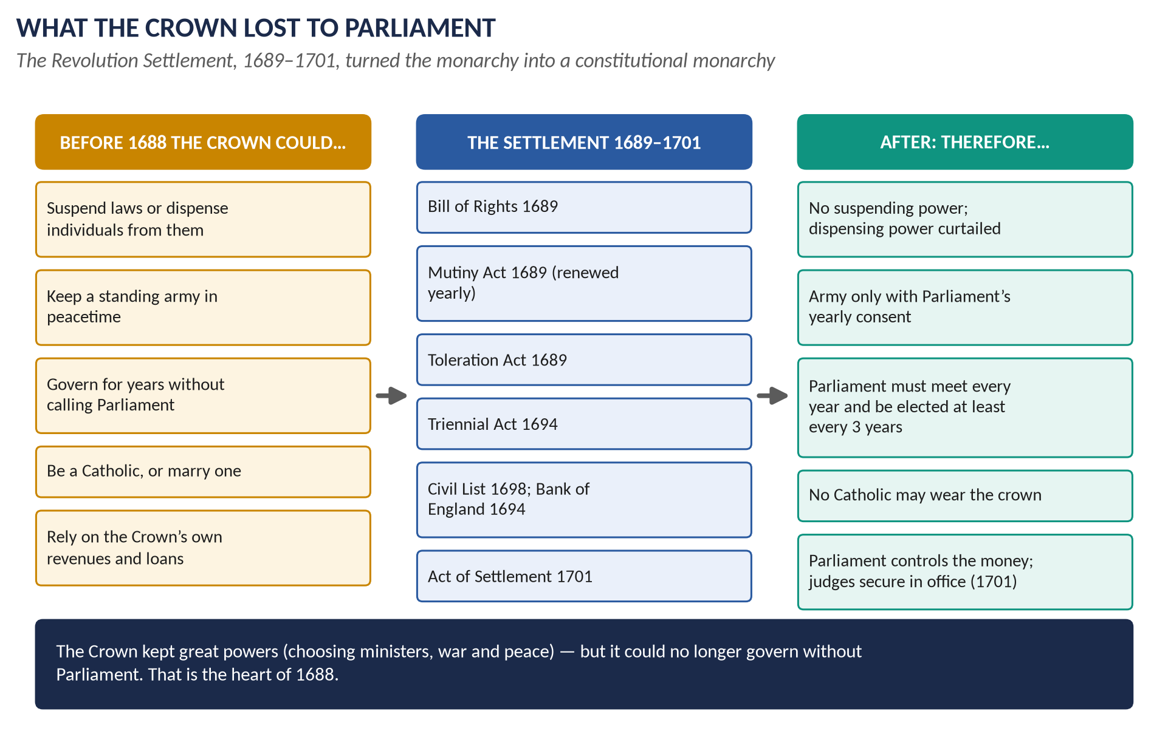
Figure 6 · What the Crown lost to Parliament: the powers of the monarchy before 1688, the laws of the Settlement, and the position afterwards.

3.2 The Financial Revolution
- War cost about £5 million a year in the 1690s — far more than the Crown's income.
- Land tax (1692) and excise duties voted by Parliament.
- Bank of England (1694): lent £1.2 million to the government at 8% in return for a charter.
- National Debt: long-term loans guaranteed by Parliament, repaid from specific taxes. Lenders trusted a Parliament of property-owners more than a king.
- Result: Britain could borrow cheaply and fight long wars — the foundation of its rise to great power (the "fiscal-military state", John Brewer).

3.3 What the Settlement did — and did not — do
What it DID | What it did NOT do
Ended the suspending power and peacetime armies without consent | Create democracy — about one adult man in five could vote
Made Parliament meet every year | Create cabinet government or a prime minister (that came under Walpole)
Put Crown finance under Parliament | Remove the monarch's power to choose ministers and make war
Secured a Protestant succession | Give toleration to Catholics
Made judges independent (1701) | Apply to Ireland, where Catholics lost almost all rights

VERDICT · The significance of the Settlement
The Settlement made England a constitutional monarchy: the Crown kept great powers, but it could no longer govern without Parliament. Every later reform — cabinet, prime minister, the Reform Acts — grew out of the fact that after 1689 Parliament met every year and held the purse.

WHAT THE EXAMINER HAS ASKED · Where Chapter 3 has been asked
Inside 2019 Q2 (significance) and 2023 Q2 (fallout at home). A full question on the Settlement or the Act of Settlement has never been set — a likely surprise (see the predicted questions in T1QA). MCQ: the Bill of Rights affirmed parliamentary supremacy (2025); the Act of Settlement secured the crown for Hanover (2026).

Chapter 4 · The Church after 1688: Non-Jurors, High Churchmen and Latitudinarians

4.1 The problem the Revolution created for the Church
- The Church of England had taught for a generation the doctrine of passive obedience (never resist the Lord's anointed) and indefeasible hereditary right (the rightful king's claim cannot be cancelled).
- In 1689 every clergyman was required to swear an oath of allegiance to William and Mary — while James, the anointed king, was still alive.
- How the clergy answered split the Church into three positions.

4.2 The Non-Jurors
- Who: Archbishop Sancroft, five other bishops (among them Thomas Ken of Bath and Wells, Turner of Ely, White of Peterborough, Frampton of Gloucester, Lloyd of Norwich) and about 400 clergy; also some laymen.
- What they did: refused the oath ("non-juring"); deprived of their offices in 1690–91.
- Ideology: oaths are sacred; James was still king by divine and hereditary right; a Parliament cannot make a king; the Church is a spiritual society that the State cannot purge.
- Politics: most were not active plotters, but they were natural allies of the Jacobites; they kept a separate line of bishops until the late 18th century.
- Irony: several had been among the Seven Bishops who defied James in 1688 — they would resist his policies but not his right.

4.3 The High Churchmen
- Who: the majority of the parish clergy and Tory gentry; leaders such as Francis Atterbury and later Henry Sacheverell.
- What they did: took the oath, usually accepting William as king de facto (in fact) or by providence, not by the people's choice.
- Ideology: the Church's divine authority and privileges; bishops and the sacraments; hostility to Dissenters and to the "occasional conformity" by which Dissenters qualified for office.
- Politics: the Tory party. They campaigned for the Occasional Conformity Act (1711) and the Schism Act (1714), and fought for the powers of Convocation (the Church's own parliament). Their great moment was the Sacheverell trial (1710): "the Church in danger!"

4.4 The Latitudinarians
- Who: John Tillotson (Archbishop of Canterbury 1691–94), Gilbert Burnet (Bishop of Salisbury), Edward Stillingfleet, Thomas Tenison.
- What they did: welcomed the Revolution; filled the bishoprics left by the Non-Jurors.
- Ideology: "latitude" (breadth): reason, moderation and morality over disputed doctrine; a broad Church that could "comprehend" moderate Dissenters. Their Comprehension Bill (1689) failed; they supported toleration instead.
- Politics: the Whigs; they accepted William by a contract or by the needs of the Protestant religion.

4.5 The three compared
Point | Non-Jurors | High Churchmen | Latitudinarians
The oath to William | Refused | Took it (de facto) | Took it gladly
Divine right | Indefeasible, still owed to James | Believed in it, bent it to accept William | Played it down; contract and Protestant need
The Revolution | Unlawful | Accepted, uneasily | Providential and right
Dissenters | Hostile | Hostile; wanted restrictions | Tolerant; wanted to include them
Church and State | Church independent of the State | Church allied with, and privileged by, the State | Church serving a Protestant State
Party | Jacobite fringe | Tory | Whig
Fate | Deprived; slowly died out | Dominant in parishes; lost power after 1714 | Dominant among bishops after 1689 and again after 1714

WHAT THE EXAMINER HAS ASKED · Where Chapter 4 has been asked
2021 Q2: "What were the political and ideological differences among Non-Jurors, High Churchmen and Latitudinarians?" — answered in T1QA with a full comparison.

Chapter 5 · William III and the Nine Years' War, 1689–1702

5.1 William as king
- Character: cold, asthmatic, brilliant as a diplomat, devoted to the Protestant cause in Europe. He never became popular in England; he preferred his Dutch favourites (Bentinck, Keppel).
- Priorities: England was, for him, the means to defeat Louis XIV. He accepted limits on his power in return for money and men.
- Parties: he tried to govern with both Whigs and Tories. In the mid-1690s he relied on the Whig "Junto" (Somers, Montagu, Russell, Wharton), who backed the war and the new finance.
- Parliament gained because the war made William dependent on it: annual sessions, supply, the Triennial Act (1694), the Civil List (1698) and, in 1701, the Act of Settlement.

5.2 The War of the League of Augsburg (the Nine Years' War), 1688–1697

Causes — the long road
1. Louis XIV's expansion: the War of Devolution (1667–68), the Dutch War (1672–78), and the Réunions (1679–84), by which French courts "reunited" border lands to France — including Strasbourg (1681).
2. The Truce of Ratisbon (1684) left Louis's gains in place for twenty years; the German princes feared more.
3. The Revocation of the Edict of Nantes (1685) turned Protestant Europe against Louis.
4. The League of Augsburg (July 1686): the Emperor Leopold I, Spain, Sweden, Bavaria, Saxony and the Palatinate agreed to defend the Empire's borders.

Causes — the trigger
1. Disputes over the Palatinate (Louis claimed lands for his sister-in-law) and the Electorate of Cologne (Louis's candidate was rejected by the Pope in 1688).
2. September 1688: Louis attacked Philippsburg and the Rhineland, hoping for a short war.
3. November 1688: William took England — which Louis had not expected.
4. May 1689: England declared war on France and joined the Grand Alliance (the Emperor and the Dutch, Treaty of Vienna, May 1689; later Spain and Savoy).

The course of the war
Theatre | Events | Result
Ireland | Derry 1689; the Boyne 1690; Aughrim and Limerick 1691 | Ireland secured for William; Louis's "back door" closed
At sea | Beachy Head (June 1690): French victory; Barfleur–La Hogue (May–June 1692): Anglo-Dutch victory | French invasion plans ended; the allies command the Channel
Flanders | Fleurus (1690), Steenkerque (1692), Neerwinden/Landen (1693): French victories; William retakes Namur (1695) | A war of sieges; stalemate
Home front | Land tax 1692; Bank of England 1694; National Debt; recoinage 1696 | England learns to pay for long wars

By 1697 France was exhausted by war and by the terrible famine of 1693–94; the allies were exhausted too. Both sides needed peace.

The Treaty of Ryswick, September 1697
1. Louis recognised William III as King of England, Scotland and Ireland, and promised not to support his enemies (James).
2. France returned most of the Réunions and conquests since Nijmegen (1678) — but kept Strasbourg.
3. Lorraine restored to its duke.
4. The Dutch gained the right to garrison barrier fortresses in the Spanish Netherlands.
5. Colonial conquests (in America and India) were returned on both sides.

The significance of the war and the treaty
- The Revolution secured: Louis's recognition made William's title — and the Revolution — part of the European order.
- Britain a great power: for the first time England fought as a principal in a major continental war.
- The Financial Revolution was born of this war.
- Only a truce: Ryswick said nothing about the Spanish succession, the real prize. Two Partition Treaties (1698, 1700) tried to share the Spanish empire; Charles II of Spain's will of 1700 wrecked them.
WHAT THE EXAMINER HAS ASKED · Where Chapter 5 has been asked
2015 P1 Q3: "Account for the War of the League of Augsburg followed by the Treaty of Ryswick." MCQ 2024: "The League of Augsburg was signed in…" — none of the options was right; the League was formed in 1686.

Chapter 6 · Queen Anne and the War of the Spanish Succession, 1702–1714

6.1 Anne as queen
- Character: devout Anglican, shy, often ill; strong-willed when her Church or her prerogative was touched. "I know my heart to be entirely English" (her first speech, 1702) — a pointed contrast with Dutch William.
- Her ministers: at first the "duumvirate" of Marlborough (army) and Godolphin (Treasury), with Tory then increasingly Whig support; from 1710 the Tories Harley and St John.
- Her favourites: Sarah Churchill, Duchess of Marlborough (until their quarrel, c.1707–10), then Abigail Masham, Harley's cousin.
- Her reign's great achievements: victory over France, the Union with Scotland, and a secure Protestant succession.

6.2 The causes of the War of the Spanish Succession
1. Charles II of Spain died childless in November 1700; his will left all his empire to Philip, Duke of Anjou, Louis XIV's grandson.
2. Louis accepted the will — and kept Philip's right to the French throne.
3. French troops occupied the barrier fortresses in the Spanish Netherlands (1701); French merchants gained the Spanish asiento — a threat to English and Dutch trade.
4. When James II died (September 1701), Louis recognised his son as "James III" — an insult to the Act of Settlement.
5. The Grand Alliance was renewed at The Hague (September 1701); after William's death England declared war in May 1702.
KEY IDEA · The principle at stake
If one family ruled France and Spain with their empires, no power in Europe could resist it. The war was fought for the balance of power — and for British trade.

6.3 The course of the war
Year | Event | Significance
1704 | Blenheim (13 August): Marlborough and Prince Eugene destroy a Franco-Bavarian army | Saves Vienna; knocks Bavaria out; first great French defeat in half a century
1704 | Gibraltar taken by Admiral Rooke | Britain's key to the Mediterranean
1706 | Ramillies | Most of the Spanish Netherlands conquered
1706 | Turin (Eugene) | France driven out of Italy
1707 | Almanza | Allied defeat in Spain — Philip cannot be removed
1708 | Oudenarde; siege of Lille; Minorca taken | Allies on France's northern border
1709 | Malplaquet | Allied "victory" costing some 20,000 allied casualties; the war becomes unpopular
1710 | Brihuega | British army in Spain surrenders

Why Britain won the war's battles
- Marlborough's genius: mobility, surprise, cooperation with Eugene.
- Money: the new public credit let Britain pay its own armies and subsidise its allies.
- Sea power: control of the Mediterranean and the Channel.

6.4 How Anne changed the course of the war
1. The peace offer of 1709 failed: the allies demanded that Louis help expel his own grandson from Spain; Louis refused. "No peace without Spain" became the Whig slogan — and a trap.
2. War-weariness: taxes, casualties, bad harvests.
3. The Sacheverell trial (1710): the Whigs impeached a High Church preacher who attacked the Revolution's principles; his light sentence was a public triumph for the Tories.
4. Anne dismissed the Whigs and appointed Harley (1710); the Tories won the election of October 1710.
5. Secret talks with France (1711); Marlborough dismissed (December 1711).
6. Twelve new Tory peers created at once to carry the peace through the Lords.
7. The "restraining orders" (1712): the British commander (Ormonde) was told not to fight — deserting the allies. Continental Europe called it the treachery of "perfidious Albion".

6.5 The Peace of Utrecht, 1713 (and Rastatt, 1714)
Party | What it gained or accepted
Spain | Philip V keeps Spain and its American empire — but renounces the French throne for ever
France | Keeps its core; recognises the Protestant succession and expels "James III"; demolishes the fortifications of Dunkirk
Austria (Rastatt 1714) | The Spanish Netherlands, Milan, Naples and Sardinia
Savoy | Sicily and a royal title
Dutch | A barrier of fortresses — but no major gains
Britain | Gibraltar and Minorca; Newfoundland, Nova Scotia (Acadia) and Hudson Bay from France; St Kitts; the asiento for 30 years and trading rights in Spanish America

6.6 The impact on the balance of power
1. French hegemony checked: Louis's attempt to dominate Europe was ended; the French and Spanish crowns were kept apart.
2. Spain divided: its European empire was broken up; Spain became a second-rank power.
3. Austria rose as the great power of central Europe and Italy.
4. The Dutch declined, exhausted by two long wars.
5. Britain rose as the leading naval and commercial power — with bases (Gibraltar, Minorca), colonies and trade.
6. The principle itself entered international law: the Anglo-Spanish treaty spoke of securing the peace of Christendom by a "just equilibrium of power" (justo potentiae aequilibrio). It shaped British policy for two centuries (see Topics 3 and 6).
WHAT THE EXAMINER HAS ASKED · Where Chapter 6 has been asked
2025 Q2: "Discuss the significance of Queen Anne's reign in shaping the course of the War of Spanish Succession and its impact on the balance of power in Europe." Answered in T1QA.

Chapter 7 · The Union of England and Scotland, 1707
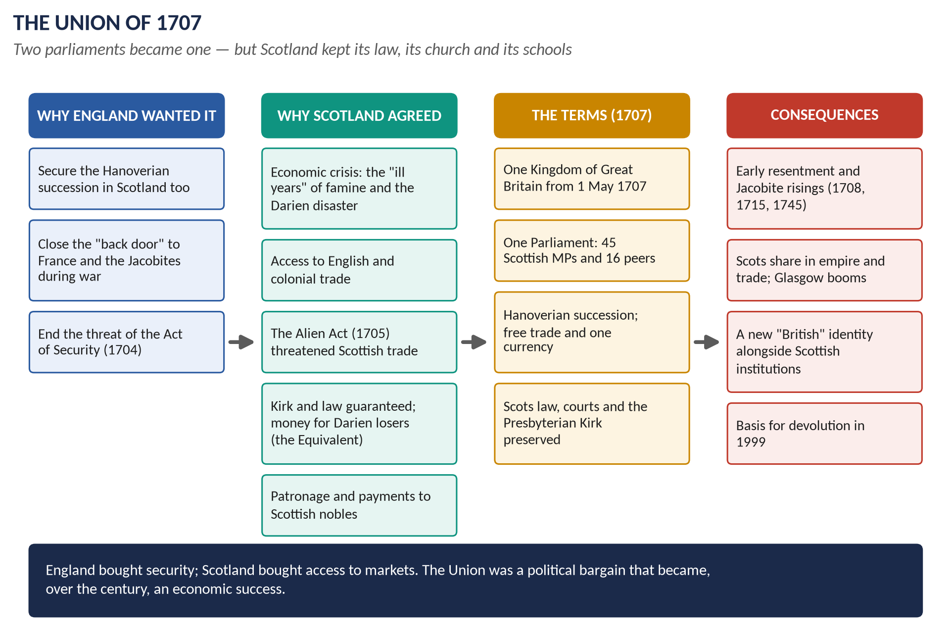
Figure 7 · The Union of 1707: why each side wanted it, its terms and its consequences.

7.1 Two kingdoms, one king (1603–1707)
- From 1603 the two countries shared a monarch but kept separate parliaments, churches, laws, currencies and trade.
- Cromwell forced a union in the 1650s; it ended at the Restoration.
- After 1689 the Scottish Parliament became much more independent: the Claim of Right had abolished the "Lords of the Articles" through which kings had controlled it.

7.2 The crisis of 1698–1705

The Darien disaster
- The Company of Scotland tried to found a trading colony at Darien on the isthmus of Panama (1698–1700).
- Disease, Spanish attacks and English hostility (William forbade English colonies to help, to avoid offending Spain) destroyed it. About 2,000 colonists died.
- Scotland lost perhaps a quarter of its liquid capital. Anger at England ran high.
- Together with the famine of the "ill years" (1690s), it convinced many Scots that their economy could not survive alone.

The constitutional collision
Year | Measure | Meaning
1701 | English Act of Settlement | Crown to Hanover — passed without consulting Scotland
1703 | Scottish Act anent Peace and War | Scotland's Parliament to decide war and peace for Scotland after Anne
1704 | Scottish Act of Security | Scotland may choose a different successor unless its religion, trade and liberties are secured
1705 | English Alien Act | Scots to be treated as aliens and Scottish trade with England banned unless Scotland negotiates union or accepts Hanover

KEY IDEA · Why the English suddenly wanted union
In the middle of a war with France, a Scotland with a different king — perhaps the Catholic "James III" — would open a back door for French invasion. Union was, above all, security.

7.3 The treaty and its terms (1706–07)
Commissioners from both kingdoms negotiated in London (April–July 1706). The Scottish Parliament debated the treaty from October 1706 to January 1707 amid riots in Edinburgh and Glasgow; it passed by about 110 votes to 69. The English Parliament then passed it quickly.
The twenty-five articles, in summary:
1. England and Scotland united as the Kingdom of Great Britain from 1 May 1707.
2. Succession to the House of Hanover.
3. One Parliament of Great Britain at Westminster: Scotland to send 45 MPs (out of 558) and 16 representative peers.
4. Free trade and navigation throughout the kingdom and its colonies; one coinage, weights and measures.
5. Taxes equalised, with some temporary Scottish exemptions.
6. The Equivalent: £398,085 10s. paid to Scotland, partly to compensate shareholders in the Company of Scotland (Darien) and to cover Scotland's share of England's debt.
7. Scots law and courts (the Court of Session, the High Court of Justiciary) preserved.
8. A separate Act guaranteed the Presbyterian Church of Scotland.

7.4 Why the Scottish Parliament agreed
1. Economics: access to English and colonial markets after Darien and the ill years.
2. Pressure: the Alien Act threatened Scottish trade in cattle and linen.
3. Guarantees: the Kirk and Scots law were protected — the institutions Scots cared most about.
4. Management: the Duke of Queensberry and the "Squadrone Volante" (a small group that swung behind the treaty) delivered the votes; about £20,000 was paid to Scottish politicians, officially as arrears of salary — hence the charge that Scotland was "bought and sold for English gold".
5. Security: many Presbyterian Scots feared a Jacobite and Catholic restoration more than union.

7.5 The consequences

Political
- Early resentment: the malt tax (1713) so angered Scots that a motion in the Lords to dissolve the Union failed by only four votes.
- Jacobitism fed on anti-Union feeling: the failed French landing of 1708, the risings of 1715 and 1745 (Topic 2).
- Scotland was governed through patronage by "managers" such as the Duke of Argyll.

Constitutional
- An incorporating union (one Parliament), not a federal one — Scotland's Parliament simply ceased to exist.
- Yet Scotland kept its own law, courts, church and schools: one state, two civil societies.
- English lawyers treated the new Parliament as the old English one continued, with parliamentary sovereignty; Scottish lawyers argued the Treaty was a fundamental law that Parliament could not break. The debate returned in the 20th century.
- Scotland's surviving institutions were the basis for devolution and the new Scottish Parliament in 1999.

Economic and social (supporting evidence)
- Slow gains at first; after 1750 rapid growth: the Glasgow tobacco trade, linen, and Scots in the Empire and the army.
- The Scottish Enlightenment (Hume, Adam Smith) flourished in the new Britain.
- A shared "British" identity grew alongside Scottish identity — built, Linda Colley argues, on Protestantism, war with France and empire.
WHAT THE EXAMINER HAS ASKED · Where Chapter 7 has been asked
2021 Q3: "What were the political and constitutional causes and consequences of the Act of Union 1707?" MCQs: the Act of Union took effect in 1707 (2024); was passed in 1707 (2025).

Part Four — Historians and Quotations

4.1 The historians
Historian | The view to quote
Thomas Babington Macaulay, History of England (1848–61) | "Of all revolutions the least violent, it has been of all revolutions the most beneficent": it preserved liberty by being conservative. The classic Whig view.
G. M. Trevelyan, The English Revolution 1688–1689 (1938) | "Glorious" because bloodless and because it settled the constitution without a social upheaval.
Christopher Hill | The Revolution completed the victory of the propertied classes begun in the 1640s.
J. R. Jones, The Revolution of 1688 in England (1972) | James's policies were more radical than the Whigs admitted; the Revolution was essentially a Dutch invasion accepted by the elite.
John Miller, James II (1978) | James wanted toleration and equality for Catholics, not a Catholic tyranny — but his methods were fatal.
Jonathan Israel (ed.), The Anglo-Dutch Moment (1991) | The invasion was a Dutch strategic operation to bring England into the war against France.
J. H. Plumb, The Growth of Political Stability in England 1675–1725 (1967) | The years after 1688 were unstable; stability came only with the Whig supremacy after 1715.
John Brewer, The Sinews of Power (1989) | The Revolution created the "fiscal-military state" that made Britain a great power.
Tim Harris, Revolution (2006) | A revolution in three kingdoms: glorious in England, violent in Scotland and Ireland.
Steve Pincus, 1688: The First Modern Revolution (2009) | A genuine, popular, transforming revolution — not a conservative coup.
Linda Colley, Britons (1992) | Protestantism, war with France and empire forged the British identity that made the Union work.

4.2 Lines worth quoting
"Of all revolutions the least violent, it has been of all revolutions the most beneficent." — Macaulay, on 1688
"Having endeavoured to subvert the constitution of this kingdom by breaking the original contract between king and people… [James] has abdicated the government, and the throne is thereby vacant." — House of Commons, 28 January 1689
"The pretended power of suspending of laws or the execution of laws by regal authority without consent of Parliament is illegal." — The Bill of Rights, 1689, first article
"I know my heart to be entirely English." — Queen Anne, first speech to Parliament, 1702
"There's ane end of ane auld sang." — Lord Seafield, Chancellor of Scotland, signing the Union, 1707
"We're bought and sold for English gold — such a parcel of rogues in a nation!" — Robert Burns, on the Union (1791)

Part Five — The Examiner's Record
Every descriptive question set on this topic, 2015–2026. Each is answered in full in the companion document T1QA, with its answer map.
Paper | The question as set | Family | Type
2015 · Q2 · Paper I | What forced James II to issue the various Declarations of Indulgence? | The Glorious Revolution | Causes / results
2015 · Q3 · Paper I | Account for the War of the League of Augsburg followed by the Treaty of Ryswick. | William's and Anne's wars (Augsburg, Spanish Succession) | Causes / results
2018 · Q2 · Section A | What led to the occurrence of the ultra-degree of mega development towards the close of the 17th century in Britain known as the 'Glorious Revolution'? | The Glorious Revolution | Causes / results
2019 · Q2 · Section A | What was so glorious about the Glorious Revolution? Discuss its significance in British history. | The Glorious Revolution | Impact / significance
2021 · Q2 · Section A | What were the political and ideological differences among Non-Jurors, High Churchmen and Latitudinarians? | Church parties after 1688 (Non-Jurors, High Church, Latitudinarians) | Compare / contrast
2021 · Q3 · Section A | What were the political and constitutional causes and consequences of the Act of Union 1707? | Union of England and Scotland, 1707 | Causes / results
2023 · Q2 · Section A | How did the Glorious Revolution occur in Britain? What was its fallout at home and abroad? | The Glorious Revolution | Causes / results
2025 · Q2 · Section A | Discuss the significance of Queen Anne's reign in shaping the course of the War of Spanish Succession and its impact on the balance of power in Europe. | William's and Anne's wars (Augsburg, Spanish Succession) | Impact / significance

WHAT THE EXAMINER HAS ASKED · The pattern
The Revolution (causes, nature, significance, fallout) is the core — four times. The wars (Augsburg/Ryswick; Anne and the Spanish Succession) come next. The Church (2021) and the Union (2021) show the examiner reaches into every corner. Never yet asked: the Revolution Settlement as a whole, the Act of Settlement, William III's reign, Anne's domestic politics.

Part Six — The One-Liner Bank
HOW TO USE THIS · How to use the one-liners
Cover the answer (after the arrow) and say it aloud. 115 questions, grouped by chapter. Words in bold are the ones examiners test. These are not past MCQs — they are the facts behind every possible objective question on this topic. (The past MCQs are solved in T1QA.)

One-liners · Before 1685 and the ABC
1. Which king joined the crowns of England and Scotland in 1603? → James VI of Scotland (James I of England).
2. Which Stuart king was executed in January 1649? → Charles I.
3. What title did Oliver Cromwell hold from 1653? → Lord Protector.
4. In which year was the monarchy restored under Charles II? → 1660.
5. The Test Acts of 1673 and 1678 barred whom from office and Parliament? → Catholics (all who would not take Anglican communion).
6. Which invented plot of 1678 caused an anti-Catholic panic? → The Popish Plot (Titus Oates).
7. The attempt of 1679–81 to bar James from the throne is called the? → Exclusion Crisis.
8. Supporters of exclusion were nicknamed? → Whigs; its opponents → Tories.
9. What is the royal claim to set aside an Act of Parliament altogether called? → The suspending power.
10. What is the royal claim to excuse an individual from a law called? → The dispensing power.
11. Which French edict protecting Protestants did Louis XIV revoke in 1685? → The Edict of Nantes.
12. French Protestant refugees are called? → Huguenots.

One-liners · James II, 1685–1688
13. When did James II become king? → February 1685.
14. Who led the Protestant rebellion of 1685? → The Duke of Monmouth, Charles II's illegitimate son.
15. Where was Monmouth defeated in July 1685? → Sedgemoor (Somerset).
16. Which judge presided over the "Bloody Assizes"? → Judge George Jeffreys.
17. Which 1686 court case upheld the king's dispensing power? → Godden v Hales.
18. By what majority did the judges decide Godden v Hales? → Eleven to one.
19. Which bishop did James's Ecclesiastical Commission suspend in 1686? → Henry Compton, Bishop of London.
20. Which Oxford college had its Fellows expelled for refusing a Catholic president? → Magdalen College (1687).
21. When was the first Declaration of Indulgence issued? → 4 April 1687.
22. When was the Declaration reissued and ordered to be read in churches? → April–May 1688.
23. What were the "Three Questions" (1687)? → James's test of JPs and Lords Lieutenant on repealing the Test Acts.
24. Which Tory ministers, James's brothers-in-law, were dismissed in January 1687? → The Earls of Rochester and Clarendon.
25. Which Quaker leader supported James's toleration policy? → William Penn.
26. Where did James keep a large army camp near London? → Hounslow Heath.
27. Who led the petition of the Seven Bishops? → Archbishop William Sancroft.
28. When were the Seven Bishops acquitted? → 30 June 1688.
29. When was James's son James Francis Edward born? → 10 June 1688.
30. What rumour claimed the prince was smuggled into the queen's bed? → The warming-pan story.
31. Who was James II's second wife? → Mary of Modena.

One-liners · The Revolution, 1688–1689
32. Who were the "Immortal Seven"? → The seven men who signed the Invitation to William on 30 June 1688.
33. Name two of the Immortal Seven. → Danby, Devonshire, Shrewsbury, Compton, Lumley, Russell, Sydney (any two).
34. What was William of Orange's Dutch office? → Stadtholder.
35. How was William related to James II? → Nephew and son-in-law (husband of Mary).
36. Where did William land on 5 November 1688? → Torbay (Brixham), Devon.
37. What did Protestants call the wind that carried William's fleet? → The "Protestant wind".
38. About how many soldiers did William bring? → About 15,000.
39. Which future general deserted James at Salisbury? → John Churchill (later Duke of Marlborough).
40. Which daughter of James fled to join the rebels? → Anne.
41. What did James drop into the Thames when he fled? → The Great Seal.
42. When did James finally leave England for France? → 23 December 1688.
43. What was the body that met in January 1689 without a royal summons? → The Convention Parliament.
44. What two words did the Commons use about James and the throne? → He had "abdicated" and the throne was "vacant".
45. When did William and Mary accept the crown? → 13 February 1689.
46. Which document was read to them at that ceremony? → The Declaration of Right.
47. Which dynasty came to power after the Revolution? → None new: William of Orange and Mary II (a Stuart) reigned jointly — the Hanoverians began only in 1714.
48. What did the Scottish Convention call its statement against James (1689)? → The Claim of Right.
49. Which Jacobite general was killed winning at Killiecrankie (1689)? → Viscount Dundee ("Bonnie Dundee").
50. Which clan was massacred at Glencoe in 1692? → The MacDonalds (of Glencoe).
51. Which Irish city withstood a 105-day siege in 1689? → Derry (Londonderry).
52. When was the Battle of the Boyne? → 1 July 1690 (12 July, new style).
53. Which battle of 1691 was the bloodiest ever fought in Ireland? → Aughrim.
54. Which treaty ended the Williamite war in Ireland? → The Treaty of Limerick (1691).
55. What laws shut Irish Catholics out of land and office after 1695? → The Penal Laws.
56. Which historian called 1688 "of all revolutions the least violent"? → Thomas Babington Macaulay.
57. Which historian called 1688 "the first modern revolution" (2009)? → Steve Pincus.

One-liners · The Revolution Settlement
58. Which document affirmed parliamentary supremacy after the Revolution? → The Bill of Rights (December 1689).
59. What is the first thing the Bill of Rights declares illegal? → The suspending power.
60. According to the Bill of Rights, can a standing army be kept in peacetime without Parliament? → No.
61. Who does the Bill of Rights bar from the throne? → Catholics, and anyone married to a Catholic.
62. Which Act of 1689 gave Protestant Dissenters freedom of worship? → The Toleration Act.
63. Which Act made army discipline legal for one year at a time? → The Mutiny Act (1689).
64. Which Act of 1694 required elections at least every three years? → The Triennial Act.
65. When did the Licensing Act lapse, ending press censorship? → 1695.
66. When was the Bank of England founded? → 1694.
67. How much did the Bank of England first lend the government? → £1.2 million (at 8%).
68. What is the new system of public credit after 1688 called? → The Financial Revolution.
69. Which Act of 1698 fixed a yearly sum for the royal household? → The Civil List Act.
70. The Act of Settlement 1701 secured the crown for which house? → The House of Hanover.
71. Who was the Hanoverian heiress named in the Act of Settlement? → Sophia, Electress of Hanover.
72. Under the Act of Settlement, how can a judge be removed? → Only by an address of both Houses of Parliament.
73. What must the monarch be, under the Act of Settlement? → A member of the Church of England.
74. Which philosopher's Two Treatises of Government (1689) justified resistance? → John Locke.

One-liners · The Church after 1688
75. Who were the Non-Jurors? → Clergy who refused the oath of allegiance to William and Mary.
76. Which archbishop led the Non-Jurors? → William Sancroft.
77. About how many clergy became Non-Jurors? → About 400 (with six bishops).
78. What doctrine taught that subjects must never resist the king? → Passive obedience.
79. Name a leading Latitudinarian archbishop. → John Tillotson (Canterbury, 1691).
80. Name a Latitudinarian bishop who wrote a history of his own time. → Gilbert Burnet (Salisbury).
81. With which party were the High Churchmen allied? → The Tories.
82. With which party were the Latitudinarians allied? → The Whigs.
83. Which preacher's trial in 1710 caused a Tory landslide? → Henry Sacheverell.
84. Which Act of 1711 struck at Dissenters who took Anglican communion to qualify for office? → The Occasional Conformity Act.
85. Which Act of 1714 tried to close Dissenting schools? → The Schism Act.

One-liners · William III and the Nine Years' War
86. When was the League of Augsburg formed? → July 1686 (not 1689 — a 2024 MCQ trap).
87. What is the War of the League of Augsburg also called? → The Nine Years' War (1688–97).
88. Which fortress did Louis XIV attack in September 1688? → Philippsburg (Rhineland).
89. Which French naval victory came in 1690? → Beachy Head.
90. Which Anglo-Dutch naval victory came in 1692? → Barfleur–La Hogue.
91. Which fortress did William retake in 1695? → Namur.
92. Which treaty ended the Nine Years' War in 1697? → The Treaty of Ryswick.
93. What did Louis XIV recognise at Ryswick? → William III as King of England.
94. Which city did France keep at Ryswick? → Strasbourg.
95. Who were the Whig "Junto"? → Somers, Montagu, Russell and Wharton, William's Whig ministers.
96. When and how did William III die? → March 1702, after a fall from his horse.

One-liners · Queen Anne and the War of the Spanish Succession
97. When did Anne become queen? → March 1702.
98. Whom did Charles II of Spain name as heir in 1700? → Philip, Duke of Anjou, Louis XIV's grandson.
99. Where did Marlborough win his greatest victory, on 13 August 1704? → Blenheim (Bavaria).
100. Which rock did the British take in 1704? → Gibraltar.
101. Name Marlborough's victories of 1706, 1708 and 1709. → Ramillies, Oudenarde, Malplaquet.
102. Who was Anne's Lord Treasurer, partner of Marlborough? → Sidney Godolphin.
103. Which Tory leader made peace from 1710? → Robert Harley (with Henry St John, Viscount Bolingbroke).
104. Which treaty ended the war in 1713? → The Treaty of Utrecht.
105. Name four British gains at Utrecht. → Gibraltar, Minorca, Newfoundland, Nova Scotia (also Hudson Bay, St Kitts and the asiento).
106. What was the asiento? → The right to supply enslaved Africans to Spanish America (30 years).

One-liners · The Union of 1707 and the end of the Stuarts
107. When did the Act of Union between England and Scotland take effect? → 1 May 1707.
108. How many MPs and peers did Scotland send to Westminster? → 45 MPs and 16 peers.
109. Which Scottish colony in Panama failed in 1698–1700? → Darien.
110. Which Scottish Act of 1704 threatened a different successor? → The Act of Security.
111. Which English Act of 1705 threatened to treat Scots as foreigners? → The Alien Act.
112. What was the Equivalent? → £398,085 paid to Scotland at the Union (partly for Darien losses).
113. Which Scottish institutions survived the Union? → Scots law, the courts and the Presbyterian Kirk.
114. What did Lord Seafield say on signing the Union? → "There's ane end of ane auld sang."
115. When did Queen Anne die, and who succeeded? → 1 August 1714; George I of Hanover.

Part Seven — Revision Sheet · Topic 1: The Glorious Revolution and the Later Stuarts, 1685–1714
HOW TO USE THIS · How to use this sheet
This sheet is complete on its own: it can be read without the rest of the document, the night before the paper. It covers syllabus Head I (the Glorious Revolution; William III and Mary II; Queen Anne) and Head III (the Union of England and Scotland). Asked in 2015, 2018, 2019, 2021 (twice), 2023 and 2025.

R1.1 The story in ten lines
1. 1685: the Catholic James II succeeds his brother Charles II in Protestant England; he crushes Monmouth's rebellion at Sedgemoor and enlarges the army with Catholic officers.
2. 1686–87: he uses the dispensing power (upheld in Godden v Hales, 1686), purges the Church (Compton, Magdalen College) and issues the Declaration of Indulgence (April 1687), suspending the laws against Catholics and Dissenters.
3. 1688: the Declaration is reissued; the Seven Bishops refuse to read it and are acquitted (30 June); a Catholic heir is born (10 June); the "Immortal Seven" invite William of Orange.
4. 5 November 1688: William lands at Torbay; James's officers desert; James flees to France (December).
5. February 1689: the Convention declares the throne vacant and offers it jointly to William III and Mary II, with the Declaration of Right (Bill of Rights, December 1689).
6. 1689–92: war in Scotland (Killiecrankie, Glencoe) and Ireland (Derry, the Boyne 1690, Limerick 1691; then the Penal Laws).
7. 1689–97: the Nine Years' War against Louis XIV, paid for by the Financial Revolution (Bank of England 1694); ended by the Treaty of Ryswick (1697), in which Louis recognises William.
8. 1701: the Act of Settlement gives the crown after Anne to the Protestant House of Hanover.
9. 1702–13: Queen Anne's War of the Spanish Succession: Marlborough wins at Blenheim (1704); the Tories make the Peace of Utrecht (1713); Britain gains Gibraltar and Minorca and becomes the leading naval and commercial power.
10. 1707: the Act of Union creates the Kingdom of Great Britain; 1714: Anne dies and George I succeeds.

R1.2 Why the Revolution happened — the causes ranked
- Long-term: Stuart divine right against Parliament; the memory of civil war and military rule; fierce anti-Catholicism (Popish Plot 1678; Exclusion Crisis 1679–81); fear of Louis XIV's absolutism and his persecution of Protestants (1685).
- The main cause — James's policies: a large army with Catholic officers; the dispensing and suspending powers; attacks on the Church (Ecclesiastical Commission, Magdalen); the Declarations of Indulgence; an attempt to pack Parliament to repeal the Test Acts. He alienated his natural allies, the Tories and the Church.
- Triggers (June 1688): the birth of a Catholic heir and the acquittal of the Seven Bishops.
- The international cause: William needed England against Louis XIV; Louis's attack on the Rhineland (September 1688) freed the Dutch to invade.
- Verdict: James's policies made revolution possible; William's invasion made it happen.

R1.3 Why "glorious"? — and how glorious?
- For: almost bloodless in England; done by law through a Convention; preserved Protestantism and the ancient constitution; ended divine-right monarchy; founded constitutional monarchy.
- Against: a Dutch invasion (revisionists); a deal among Protestant men of property (Hill); not glorious in Ireland or Scotland — the Boyne, Glencoe, the Penal Laws (Tim Harris); Catholics got nothing.
- Historians: Macaulay ("of all revolutions the least violent… the most beneficent"); Trevelyan (glorious because bloodless); Pincus (the "first modern revolution").
- Verdict: glorious for what it settled — the Crown governs with and under Parliament — more than for how it happened.

R1.4 The Revolution Settlement, 1689–1701
Law | What it did
Bill of Rights 1689 | No suspending power; no taxes or peacetime army without Parliament; free elections and speech in Parliament; no Catholic monarch
Mutiny Act 1689 | Army legal for one year at a time → Parliament must meet yearly
Toleration Act 1689 | Worship for Protestant Dissenters (not Catholics)
Triennial Act 1694 | Elections at least every three years
Bank of England 1694 | Start of the National Debt and the Financial Revolution
Civil List Act 1698 | Crown's income voted by Parliament
Act of Settlement 1701 | Crown to Hanover; monarch Anglican; judges secure; no war for foreign lands without Parliament

Did not: create democracy (about one man in five could vote), cabinet government or toleration for Catholics.

R1.5 The Church after 1688 — three positions
- Non-Jurors (Archbishop Sancroft, six bishops, ~400 clergy): refused the oath; James still king by indefeasible hereditary right; close to the Jacobites.
- High Churchmen (Atterbury, Sacheverell): took the oath (William king de facto); defended the Church's privileges; hostile to Dissenters; Tory; Occasional Conformity Act 1711, Schism Act 1714.
- Latitudinarians (Tillotson, Burnet, Stillingfleet): welcomed the Revolution; reason, moderation, toleration; a broad Church; Whig.
- The difference in one line: could a revolution be lawful? Non-Jurors — no; High Church — reluctantly; Latitudinarians — yes.

R1.6 William's war and Ryswick (1689–97)
- Causes: Louis XIV's Réunions and seizure of Strasbourg (1681); Revocation of the Edict of Nantes (1685); the League of Augsburg (1686); Louis's attack on the Rhineland (1688); William's accession brings England in (May 1689).
- Course: Ireland secured (Boyne 1690); Beachy Head 1690 lost, Barfleur–La Hogue 1692 won; Flanders stalemate; Namur retaken 1695.
- Ryswick (1697): Louis recognises William; returns Réunions except Strasbourg; Lorraine restored; Dutch barrier.
- Significance: the Revolution secured internationally; England a great power; the Financial Revolution; but only a truce — Spain unresolved.

R1.7 Anne and the Spanish Succession (1702–13)
- Cause: Charles II of Spain's will (1700) left his empire to Philip of Anjou; Louis recognised "James III" (1701) → the balance of power at stake.
- Anne shaped the war twice: (1) by backing Marlborough and Godolphin — Blenheim 1704, Ramillies 1706, Oudenarde 1708, Malplaquet 1709; Gibraltar 1704, Minorca 1708; (2) by turning to the Tories (Sacheverell 1710; Harley and St John): Marlborough dismissed (1711), twelve peers created, separate peace — "perfidious Albion".
- Utrecht (1713): Philip V keeps Spain but renounces France; Austria gets the Spanish Netherlands and Italy; Britain gets Gibraltar, Minorca, Newfoundland, Nova Scotia, Hudson Bay, St Kitts and the asiento; France recognises the Protestant succession.
- Balance of power: France checked; Spain divided; Austria up; Dutch down; Britain the leading naval and commercial power; the principle written into the treaty.

R1.8 The Union of 1707
- Background: one king since 1603, two parliaments.
- Causes: the succession (Act of Settlement 1701 not accepted by Scotland; Scottish Act of Security 1704); war with France (fear of a Jacobite "back door"); English Alien Act 1705; Scottish economic crisis — Darien (1698–1700) and the "ill years"; management and payments (about £20,000).
- Terms: Kingdom of Great Britain from 1 May 1707; one Parliament (45 MPs, 16 peers); Hanoverian succession; free trade; the Equivalent (£398,085); Scots law, courts and Kirk preserved.
- Consequences: early resentment (1713 dissolution motion lost by four votes); Jacobite risings 1708, 1715, 1745; later prosperity (Glasgow tobacco; empire); a British identity (Colley); surviving Scottish institutions → devolution in 1999.

R1.9 Ten dates to write in every answer
1685 James II · 1686 Godden v Hales · 1687 Declaration of Indulgence · 10 & 30 June 1688 heir born; bishops acquitted; Invitation · 5 Nov 1688 Torbay · 1689 Bill of Rights · 1690 the Boyne · 1694 Bank of England · 1701 Act of Settlement · 1704 Blenheim · 1707 Union · 1713 Utrecht · 1714 George I.
VERDICT · The whole topic in one sentence
Between 1685 and 1714 England replaced a Catholic king who ruled by prerogative with Protestant monarchs who ruled with Parliament, paid for two great wars with a new financial system, united with Scotland, and emerged as Great Britain — a constitutional monarchy and a great power.

